Reports. Data composition system
Basics of DCS
The data composition system (DCS) is a powerful and flexible tool covering all major report functionality, from obtaining data from various sources to displaying the data in a user-friendly manner.
In most scenarios the report source data is located in the database. You can use 1C:Enterprise query language for specifying the data sources for the data composition system and which data is retrieved from these sources.
On the report development stage you can define the default report settings, so that users can run the report right away. At the same time a user can change the report settings manually and then run the report. At that the data composition system generates another query and presents the result in a different manner, according to the user-specified settings.
The data composition system is a set of elements, each of which corresponds to a certain stage of report execution. This way, the entire process of report execution in the data composition system is reduced to a sequential transition from one element to another, which eventually results in the final report.
Each element of the data composition system has its own declarative description, the features of programmatic access and serialization to/from XML. Such approach ensures flexible management of various report execution stages.
The main elements of the data composition system are shown in the image:
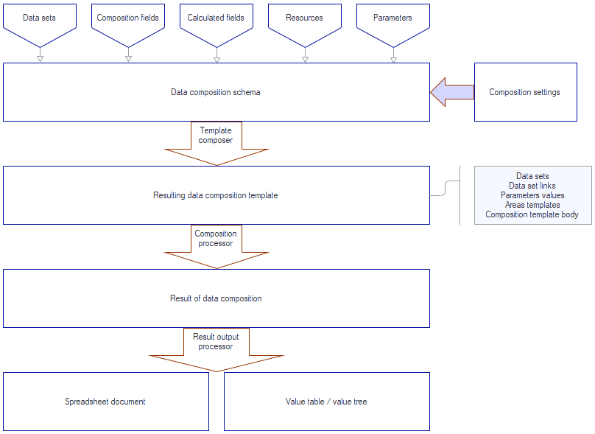
The main components of a data composition system that affect the result are the composition schema and the composition settings.
The composition schema is a basic element of the DCS, which describes all the rules for getting and processing data. The composition schema consists of a number of elements listed at the image above:
- Data sets
- Composition fields
- Calculated fields
- Resources
- Parameters
There are also additional elements of the schema, such as:
- Data set links
- Templates
- Nested schemas
These additional elements are not always used, they are used mainly for building complex reports, so let's postpone getting to know them.
The data composition settings are also a necessary element for generating a report. Composition settings describe everything that a developer or user can configure in a certain established data composition schema, i.e. they describe how exactly the data will be presented to the user.

These settings can contain:
- filter
- ordering
- conditional appearance
- report structure (components of the future report)
- data retrieval parameters
- data output parameters, etc.
The data composition template is a ready-made description of how the report should be generated. It combines the composition schema and the composition settings. In fact, it is the result of applying specific settings to the composition schema and is a ready-made task for the composition processor to generate a report of the required structure taking into account specific settings. The composition template consists of the following components:
- Data sets with resulting queries
- Data set relationships
- Parameter values
- Layouts of various report areas
- The body of the layout layout with the correspondence settings between the report structure and layouts
The composition template query is the resulting query that is generated to obtain data from the database. It is important that the composition template query may differ significantly from the composition schema data source request. For example, the composition schema contains only those fields and filters that are selected in the composition settings. Unused fields will be automatically removed from the final query (an exception to this rule are the composition fields for which the special role "Balances" is specified. We will learn about roles of fields later). Also, the composition schema query can specify the constructs of the query language extensions for the DCS, which also affect the final composition template query.
The entire report generation process is automatic. The user only needs to describe the elements of the composition schema and specify the necessary composition settings. However, it is possible to perform this process manually using the program code. Programmatic generation of reports will also be discussed later.
Since the topic "Data Composition System" is quite extensive and sometimes complex, it is easy to get confused. Therefore, I suggest moving on to a practical example to clearly understand what is what and how a report based on this mechanism works.

Simple report
I rename the Sales report to SalesTemplate (synonym: "Sales (template)") and create a new Sales report, which I include in the Sales subsystem. Next, I create a new template with the Data composition schema type. You can do this by simply clicking the magnifying glass button in the "Main data composition schema" field or the "Open data composition schema" button.
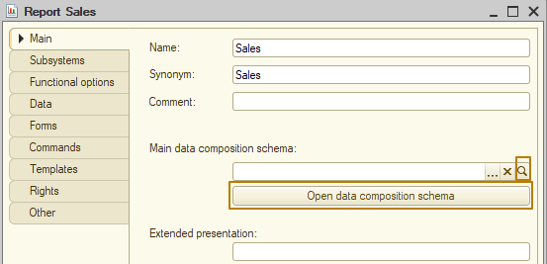
When clicked, a template creation window will open, in which the template type is already specified and cannot be changed, you can only change the template name and complete the creation by clicking the "Finish" button.
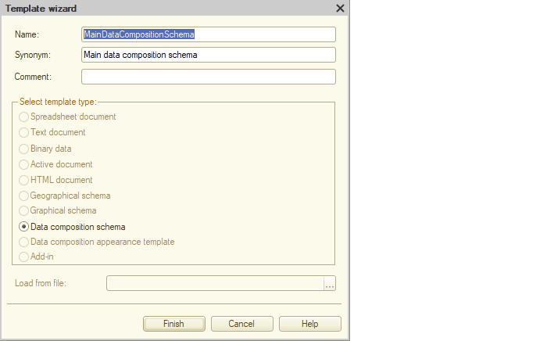

When the template is complete, you will see the opened form of this template. The first tab in the opened form is "Data sets".
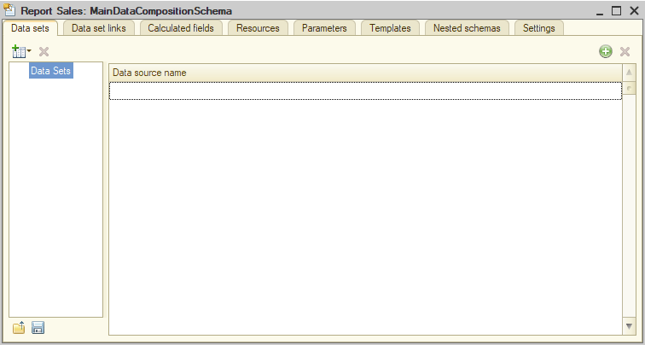
Data sets in a data composition schema contain information about which fields can be retrieved from a given data set, which data set fields can be used in filter, etc. A data composition schema may contain multiple data sets. There are three types of data sets:
1) query - data retrieval is described using a query language;
2) object - describes the name of the external data set from which the data will be retrieved. A value table, a selection from a query result, a range of cells in a spreadsheet document, a set of register records, and other sources can be used as an external data set. The most commonly used external data set is a value table due to its versatility when working from code;
3) union - is not a data set in itself, but is used to combine several data sets of any type into one, resulting data set. We can say that this data set works similarly to the union operator in a query, i.e. as a result, all records from all subordinate data sets will be selected, with the difference that, unlike the union in a query, in a data set of the "Union" type the combined data sets do not have to have the same number of fields. An example of application is the union of sales and purchase data selected from different database tables in order to display data grouped by product in a report.
All three datasets contain a number of common properties:
- Name - the name of a data set, under which this data set can be accessed from other objects in the data composition schema. Within a single data composition schema, data set names must be unique.
- Fields - descriptions of the fields available for the data set.

First, I will briefly show how to use the Union data set, and then we will move on to creating a report using the Query data set. We will look at the Object data set later.
I am adding a new Union data set:
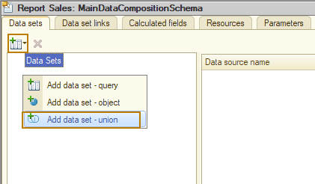
Then I add 2 more data sets of the "Query" type. Data sets can be dragged and dropped, so it's okay if, for example, your query type data set is outside the required Union type data set.
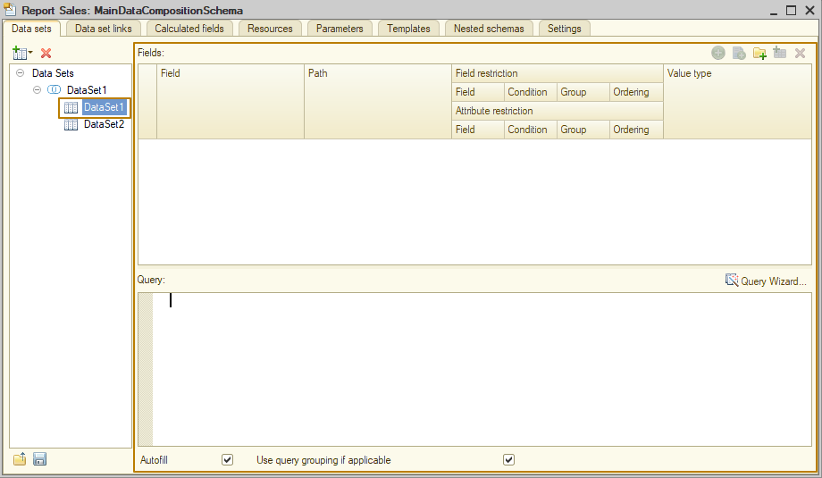
To fill in the query, you need to select a data set, I select the first data set of the Query type. The query text can be generated either using the query wizard or by inserting/writing it in the lower field.
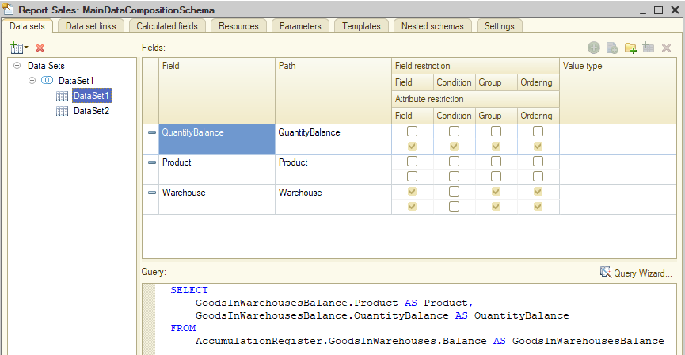
I repeat the same for the second data set.
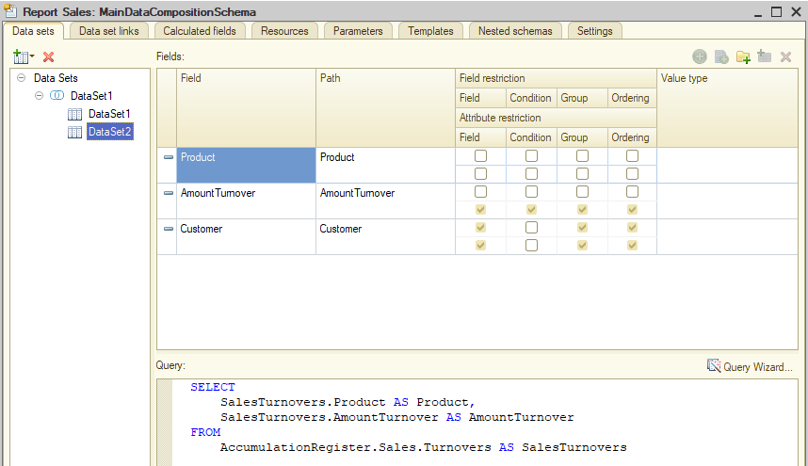
Next, I rename the data sets to more understandable ones, for this I double-click on their current names. This is how the "Union" data set looks like as a result:
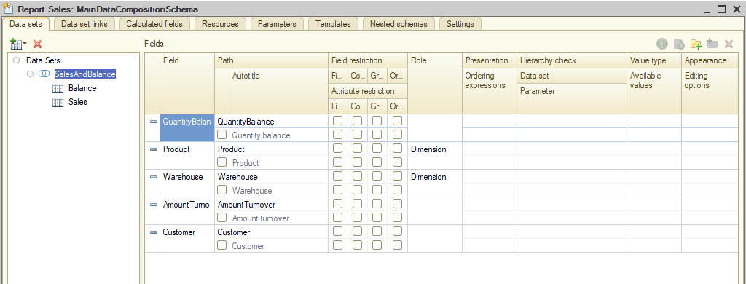
You can see that the field composition here contains all the different fields from the subordinate data sets: the data in the Product field will be taken from both subordinate data sets, the other fields are taken from the data sets separately, 2 from the first and 2 from the second.
The composition of the selected data before output to the report looks something like this (simplified example):
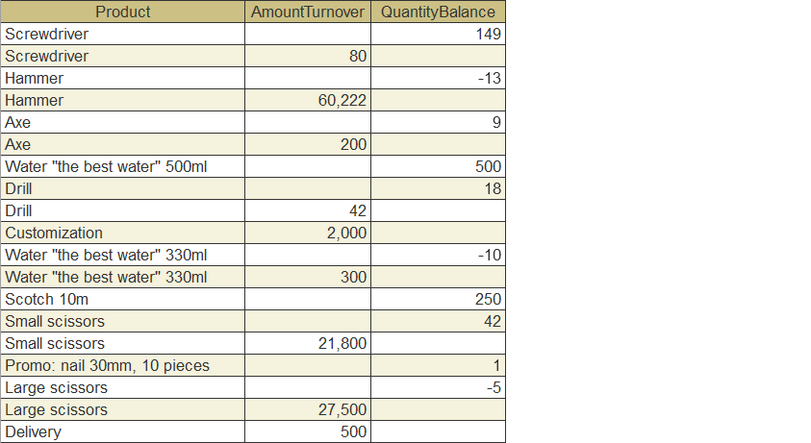
That is, the selected records are not grouped by product, so some records contain balances, and others - sales.
Grouping is performed at the following stages of report construction, which we will analyze further.
If I need to split the Product by different fields, I can do this by changing the value of the Path column in one of the data sets, for example, from Product to ProductBalance. Then in the data set of the "Union" type there will be 2 different fields: Product and ProductBalance.
Now let's get back to creating the report, so I'll delete the data sets created for the demonstration and create one new set of the "Query" type. I immediately rename it to Sales, then open the query designer and select data from the virtual table of the Sales register turnovers. Unlike the report with filling in the template from the previous lesson, I don't need totals in the query, since I can implement the same hierarchy using the data template scheme.
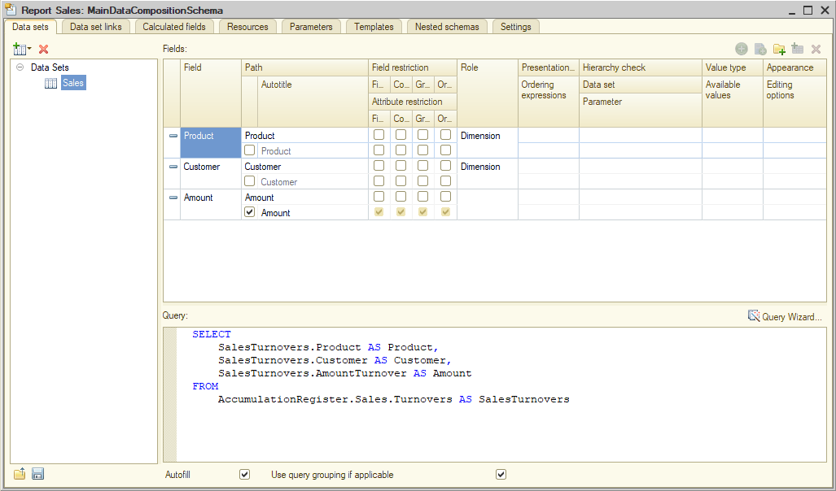
Now I go to the Resources tab, where I must specify the fields that must be calculated in some way by the groupings specified in the report (resources are essentially group or general report totals).
For each resource field, the following is specified:
Expression – a formula by which the resource value will be calculated. For example, the expression Sum(Balance) means that the aggregate function Sum, applied to the Balance field, will be used to calculate the field value. Other common aggregation functions are also available for selection, as well as custom functions in the expression language of the data composition system. For example:
- 1
- Balance / Total * 100 (for calculating percentages)
- CASE WHEN FieldValue > 1 THEN True ELSE False END
- ServerCommonModule.Function(Parameter1, Parameter2)
Yes, you can even call export function of modules!
Calculate by… – a list of groupings for which this resource will be calculated. If the property is not filled in, the resource expression will be used for all report groupings. If a certain grouping field is specified in this property, the resource is considered available only in this grouping, and this resource will not be displayed for other groupings.
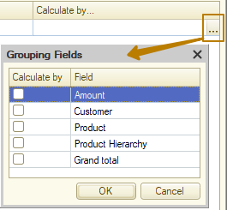
On the left is a list of available fields, to the right of this list there is a button ">>" for adding all available resources for which totals can be calculated. In my case, the Amount field should be a resource with the aggregate function Sum(), I click the button ">>" and this field is added to the right list of resources.
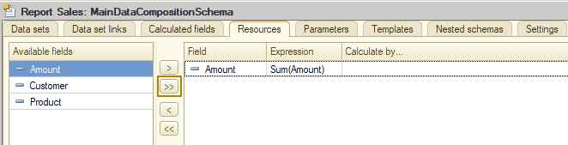
In general, even in this form, the report is almost ready for use, it remains to decide on its structure, i.e. what data needs to be output to the report, in what order to output them. To set the report structure, I go to the Settings tab and see 3 sections there:
- On the left is a list of report options. One report based on the data composition schema can contain many different report options to simplify the user's work. For example, a sales report by customers can contain an option with sales by customers, so that first of all which goods a particular customer bought, as well as an option with sales to customers by products, so that you can see which of the customers bought large/small volumes of a product.
- On the top right is the structure of groupings, tables and report diagrams.
- On the bottom right is a variety of other report settings: report parameters, selected report fields, filter, sorting, conditional appearance, custom fields, other settings.
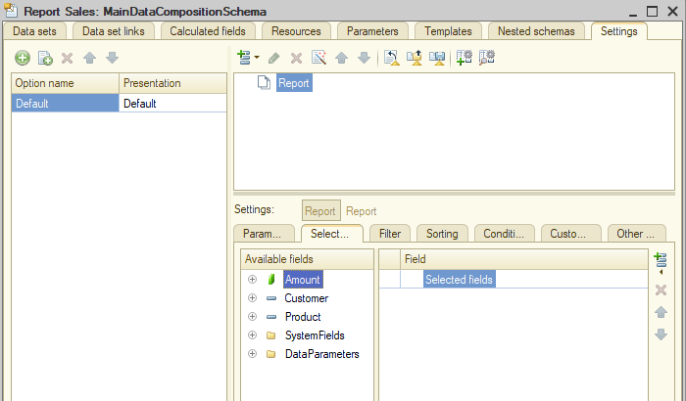
There is a settings wizard to set the report structure. As with the print form wizard, it does not cover complex cases, but my current report is simple enough, so the wizard can cope with this task.
I click the wizard button
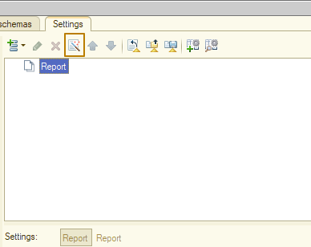
The first step provides a choice of report type: list, table, diagram.
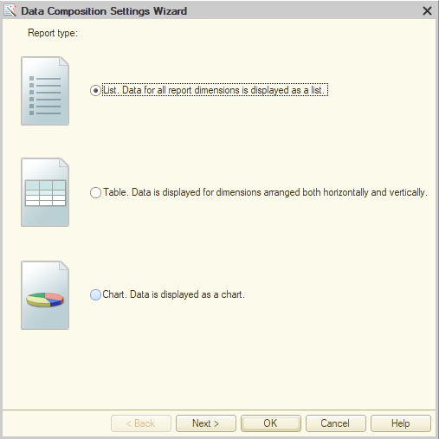
A table is used in cases where indicators are displayed at the intersection of rows and columns, for example, the balance of goods in warehouses, when the rows list goods, the columns list warehouses, and the cells at the intersection of rows and columns list the quantity of goods in the warehouse.
Example:
 | Warehouse
Product | Main | Shopping mall "New" | Shopping mall "Old" | City market
Bubble gum | 100 | 10 | 20 | 5
Lemonade "Fresh" | 50 | 7 | 1 | 3
… | … | … | … | …
It is important to understand that this type of report is not well suited for a large number of dimensions, i.e. if there are 20 or more warehouses in this example, using the report will not be very convenient.
I don't need such a structure, so I select "List" and proceed to the next step, where I need to select the fields to display in the report. Resources must be specified, and in the order in which we want them to be displayed in the report, and groupings can be omitted, because after selecting them in the next step, they will still be included in the report. But I will still indicate all the necessary fields so that the report is as accurate as possible.
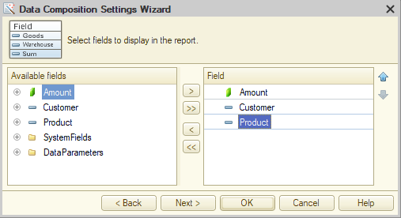
In the next step, you need to specify groupings. By analogy with the previous version of the report, I specify the Customer as the first grouping, and the Product as the second. Please note that for metadata objects that have hierarchy, you can specify the grouping type: elements, hierarchy, hierarchy only. If you specify a hierarchy, the products will be displayed with the full path to it, i.e. first the groups that the product belongs to, and then the product itself. Moreover, the totals will also be calculated for the hierarchy. I leave the value "Elements" and move on.
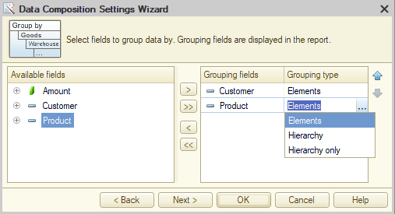
The next step allows you to specify the sorting of data in the report. Usually, it is convenient for users to see data sorted in alphabetical order. There are also reports where it is necessary to display data sorted in ascending or descending order of some indicators. For example, in descending order of the sales amount, to see which products were sold for a larger amount. If you do not specify sorting rules, the data composition system will automatically sort the data in ascending order according to the usual rules for primitive types (date, number, string, boolean) and by reference representation for reference types. If the data in the field of the CatalogReference type and for the reference in the configuration the main representation is specified as a description, then the data will be sorted by description in alphabetical order. If one grouping consists of several fields (we will consider this possibility later), this rule is applied to all fields of the grouping sequentially. I am satisfied with this behavior of the DCS, so I will not specify the sorting fields and finish the work of the wizard.
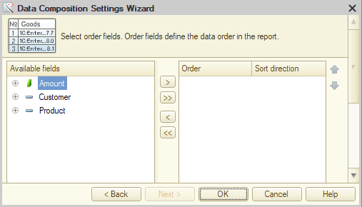
So, this is what I have got so far:
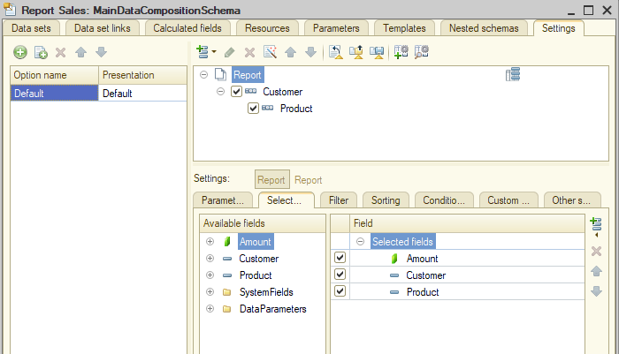
It took me literally a couple of minutes to create the report, and it's already ready to use. I don't need to create a report form, because the platform will create a default form, which will be enough for this report. I rename the report version to SalesByCustomers, then update the infobase configuration and run the report in Enterprise mode to check the result.
You can see that the new report is marked as added to Favorites. This is because the objects in Favorites are stored by their full names, and the new report received the name of the old report, which I had previously added to Favorites. Accordingly, the old report was excluded from Favorites after renaming:
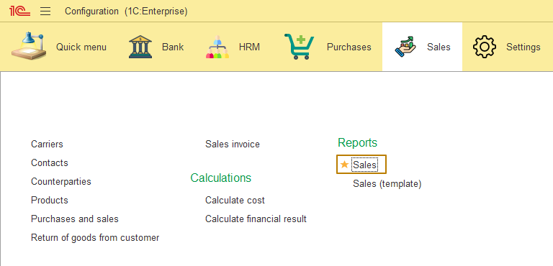
This is what the report form generated by the platform looks like:
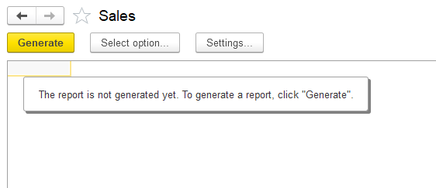
And this is what the generated report looks like:
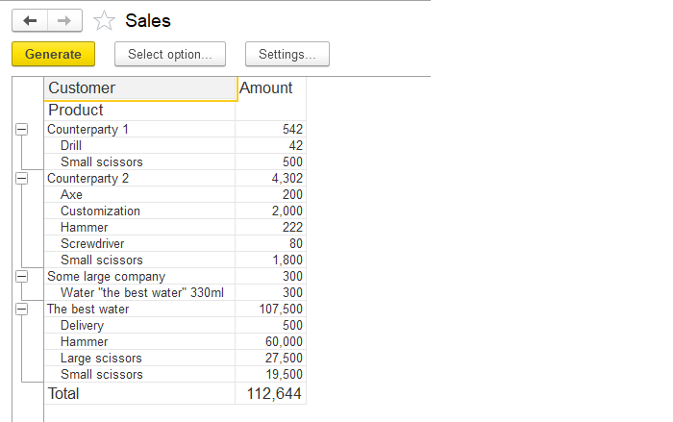
You can see that the report contains groupings of different levels, as well as totals by groupings (sales amounts by customers) and overall totals.
The "Select option…" button opens a window with a list of report options. Here we see the only version of the "Sales by customers" report:
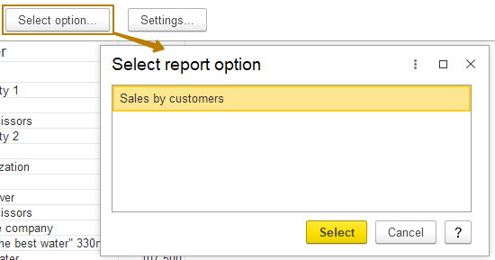
The "Settings…" button opens a window with settings available to a user. At the moment, my report does not contain such settings:
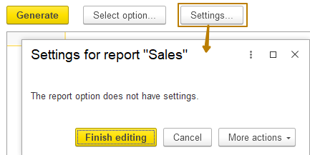
Remember, the previous report had the Period parameter and filter by products? Let's figure out how to add parameters and filters to a report based on the DCS.
I return to the Designer mode and open the "Parameters" tab of the report.
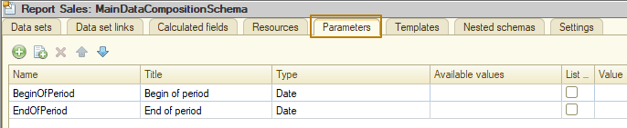
There are already 2 parameters here: BeginOfPeriod and EndOfPeriod. They appeared here automatically for several reasons:
1) In the query, I select data from the virtual table Turnovers, which has the parameters BeginOfPeriod and EndOfPeriod;
2) On the "Data sets" tab, under the query text, the Autofill flag is enabled, which is responsible for selecting all the fields used at the query to access them in the report as a resource, grouping, filter, etc. If you disable this flag, you will need to manually specify the fields selected in the report, selection fields, virtual table parameters available in the report... (we will talk about this later)
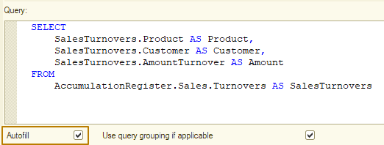
If, for example, I specify my own parameters for the beginning and end of the period in the virtual table parameters,
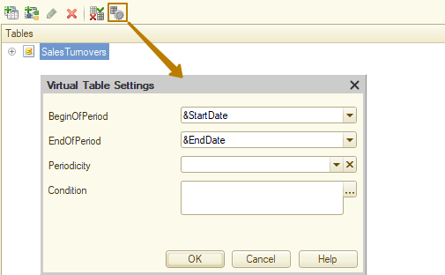
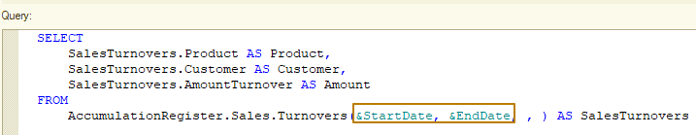
I will see that the Parameters tab already has 4 parameters, 2 created by the DCS and 2 that I specified in the query:
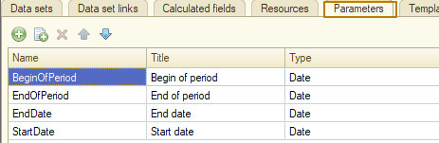
Of course, I don't need my own names for the parameters in this report, so I cancel my changes to the register virtual table parameters and move on to working on the automatically created parameters. I need to make the parameters available to the user, moreover, I want them to be displayed directly on the report form, so that there is no need to look for them somewhere in the settings.
To do this, I go to the Settings tab, and there at the bottom to the Parameters tab:
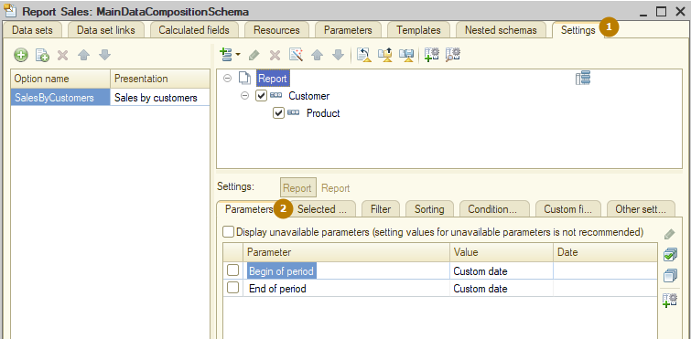
There are already parameters here, but they need to be displayed to the user. To do this, many settings, such as Parameters, Filter, Sorting, Conditional appearance have a flag "Include in custom settings", enabling which makes the setting available to the user from the settings window (the very window in which we did not have available settings). In order for the setting to get not only to a separate settings window, but also directly to the report form, you should select/keep the "Quick access" value in the "Edit mode" field:
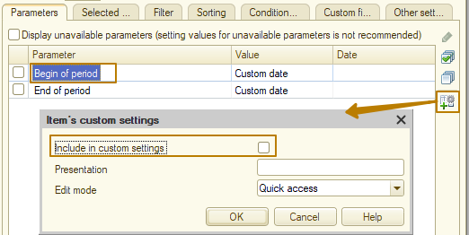
If the setting does not need to be displayed on the form, you need to select the "Normal" value. I enable this property for both parameters and leave the "Quick Access" editing mode, update the configuration and run the report in Enterprise mode.
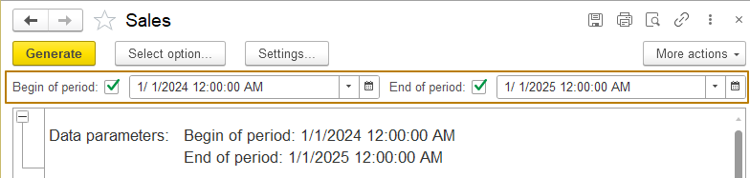
On the one hand, the parameters have appeared and they work, on the other hand, there are several inconveniences:
- Now the date contains the time, although the user rarely needs to specify the time when setting the period (but for some reports this is necessary)
- Parameters can be enabled and disabled using flags, which is unnecessary in the case of my report. I would like the parameters to be always enabled, but in the case of unfilled period parameters, the report would be generated without a period limit.
I return to the Parameters tab and in the "Type" column for the parameters, I click the selection button
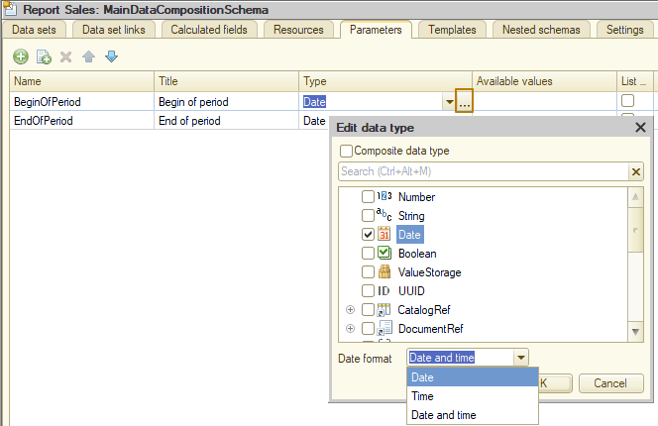
In the window that opens, I specify "Date" in the "Date format" field, then repeat the procedure for the second parameter. Next, I want these parameters to always be enabled, so that there are no extra flags on the form to enable and disable them. To do this, in the "Usage" column, I need to specify the value "Always" instead of "Auto".
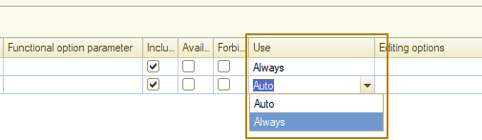
I check the result, now there is no time in the dates, and the parameters do not contain flags to enable/disable them, they are always enabled:
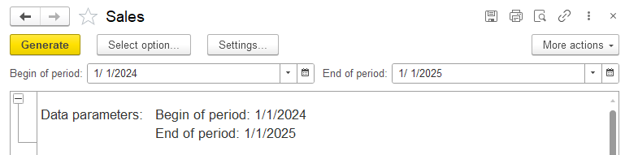
I check how the report is generated with empty period values: everything is correct, all data is displayed in the report without restrictions, and the parameters are displayed empty in the report header:
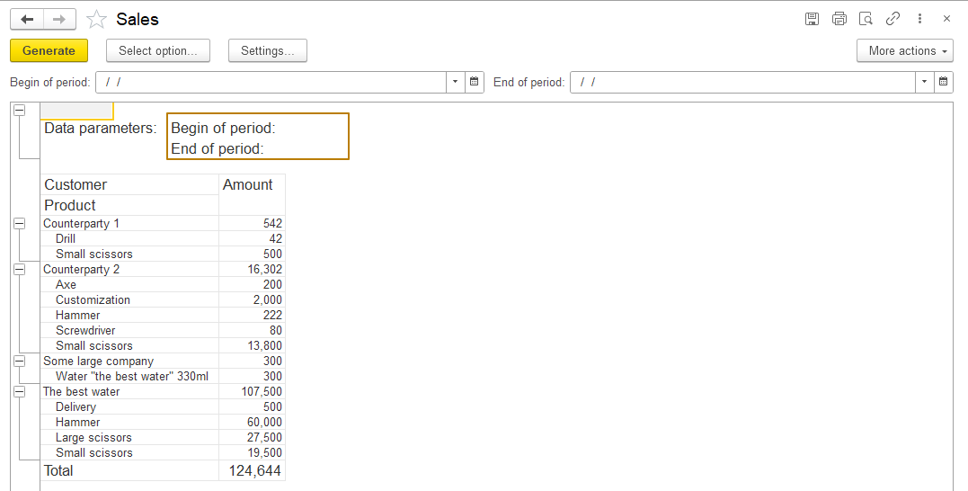
The report selects all data with an empty period due to working with a virtual table of register turnovers. The table is designed in such a way that when an empty date is passed as a start date, the start date is considered to be unlimited, the same for the end date.
However, after disabling the time in the date, I encountered another problem - usually when generating a report from the start date to the end date, it is implied that the report is generated from the beginning of the day of the start date to the end of the day of the end date, but in my case it is generated by the beginning of the day of the end date. In order for the report to be generated by the end of the day of the end date, I can use the "Expression" column in the parameter table.
Here, the language of the data composition system is supported, which partially overlaps with the built-in 1C language. In order to bring the date to the end of the day, I need to use the expression EndOfPeriod(<Period>, <PeriodType>), which accidentally coincides with the name of my parameter. As a period parameter for this method, you need to specify the parameter itself, the name of which is written after the & symbol, and the period type is specified by a string, in my case it is "Day", if you need to bring the date to the end of the month, you should enter "Month", etc.:
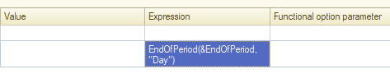
Now the report is correctly generated when the period is filled, but when the values are empty, the report does not contain data. This is because the parameters of the virtual table of the register are no longer receive an empty date, but the end of the day 1.1.0001 (23:59:59), i.e. a limitation is imposed on the end date parameter of the virtual table. What can be done to avoid this:
- Write a more complex expression with a check for an empty date:
CASE WHEN &EndOfPeriod = DateTime(1, 1, 1) THEN DateTime(1, 1, 1) ELSE EndOfPeriod(&EndOfPeriod, "Day") END
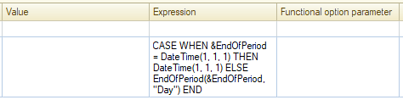
- Use a standard period, since it automatically adjusts the end date to the end of the day if it is not empty
Since the standard period is convenient to use anyway (we already used it in the report with filling the template), I will use this option.
I create my own Period parameter with the StandardPeriod type, then enable the always use property for it. Now I need to do the following: since the user will use the period, I should disable the ability to use the BeginOfPeriod and EndOfPeriod parameters them, but the values of these parameters need to be filled with the values of the start date and end date of the standard period, because these parameters are passed to the query when it is executed. Let's start with restricting the use for the user, this can be done by setting the flag in the "Availability restriction" column. It is better to disable the flags in the "Include in available fields" column, as well as return the Auto value in the "Usage" column:
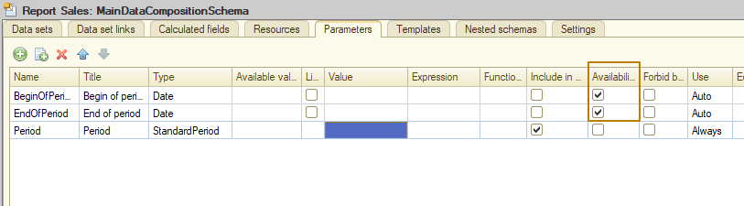
Now I need to pass the values of the standard period to the BeginOfPeriod and EndOfPeriod parameters, I do this again using the "Expression" field - I access the Period parameter and get the values of its StartDate and EndDate properties: &Period.StartDate, &Period.EndDate
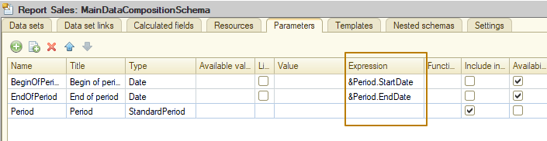
Now we need to include the Period parameter in the settings available to the user in the Settings - Parameters tab, we already know how to do this - by setting the "Include in custom settings" flag:
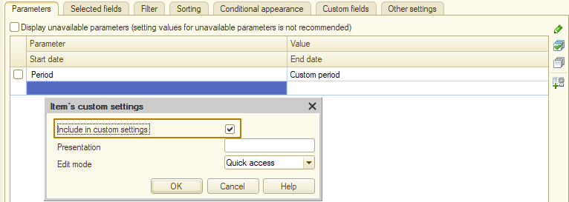
I update the configuration and run the system in Enterprise mode to check.
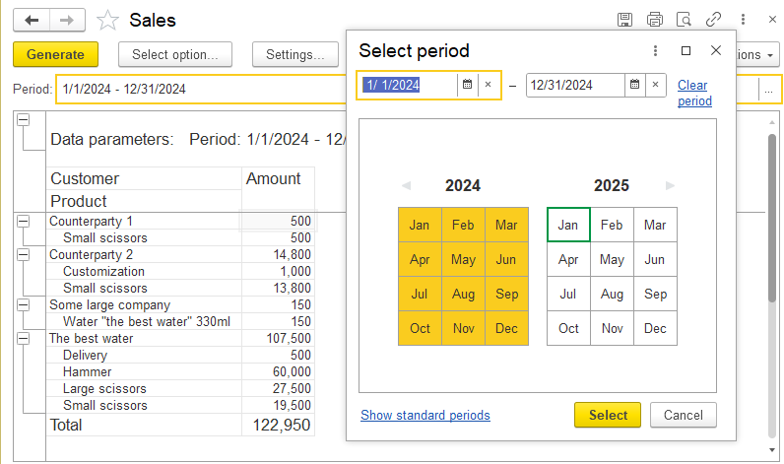
Now everything works exactly as I intended. Let's immediately look at the settings available to the user:
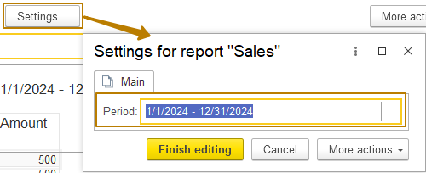
We see that the period parameter is now available in the report settings, which means that working with the parameter is finished.
Let's move on to adding a filter by product. Everything is as simple as possible with it, I need to add a filter on the Filter tab, and then include it in the custom settings with the "Quick access" mode. But before I do this, I want to show how users can independently customize the report for themselves, which is one of the strengths of the data composition system.
A user can open all the report settings, for this he must open the "More actions" submenu and click the "Change option..." button, then a window will open that is almost identical to what the "Settings" tab of the data composition schema looks like in the Designer mode.
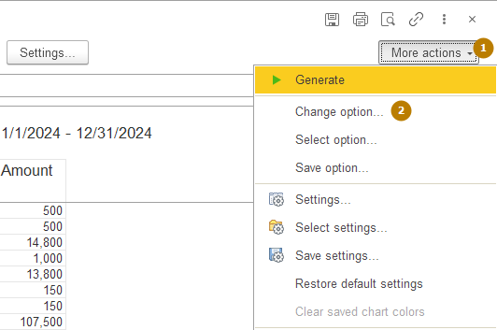
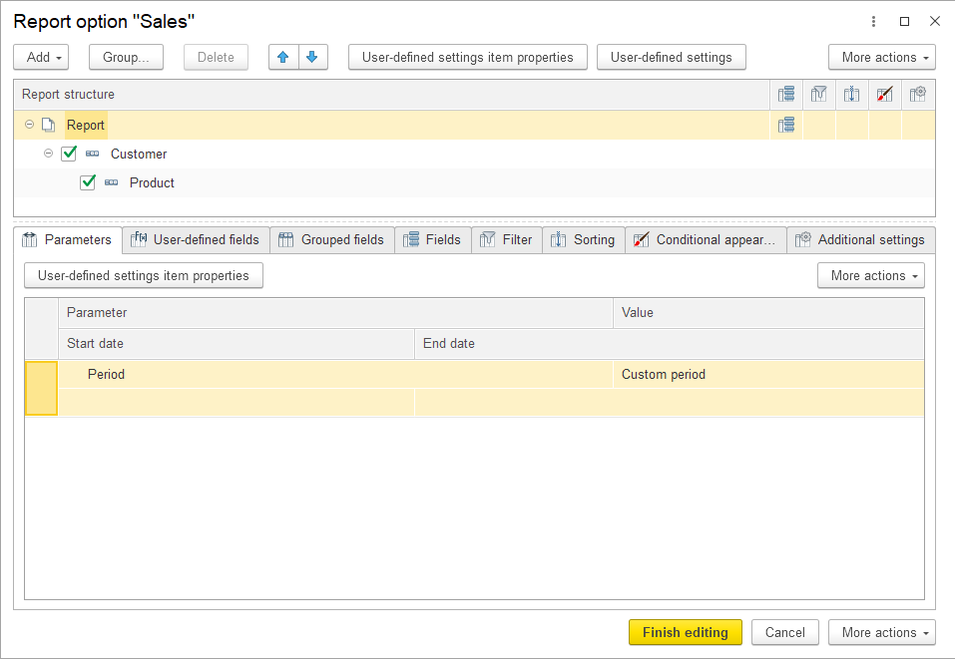
Here I go to the Filter tab and add a filter by Product, select the "In the list" comparison type:
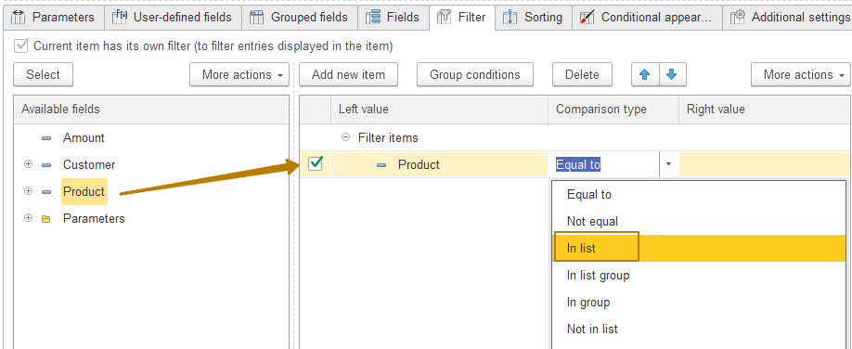
Then I remove the use flag so that my filter is disabled by default, at the end I include this filter in the custom settings with quick access so that it is displayed on the form.
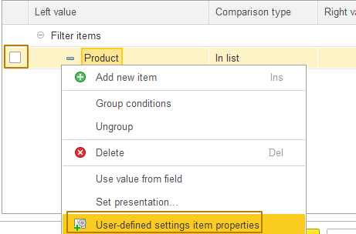
I click "finish editing" and see the filter on the form, so I try to use it. Everything works, now the user can change the filter, comparison type directly on the form, enable and disable it.
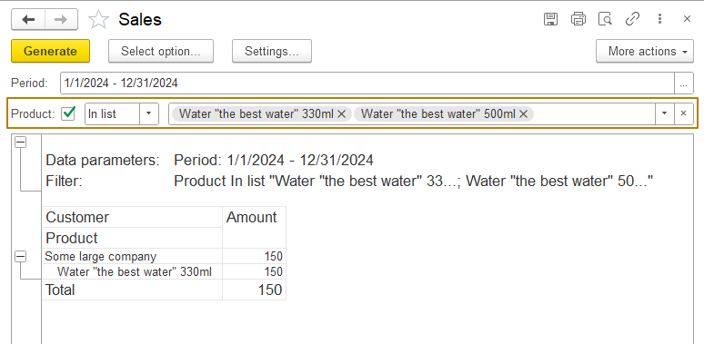
Other users will not see this filter, and the current user can save the report option so that the filter will remain on the form the next time it is opened. I will not stay on saving a report variant now, since modern configurations use advanced report variants included in the Reports subsystem from the Standard Subsystems Library, which provide extensive capabilities for working with report variants, including saving for all or a limited list of users. So there is simply no point in studying irrelevant functionality.
So, in order for all users to be able to use the filter by product at once, I should add the filter to the report at the configuration level. This is done in the same way as I just did in the Enterprise mode, so I will not repeat myself, the screenshot shows the result:
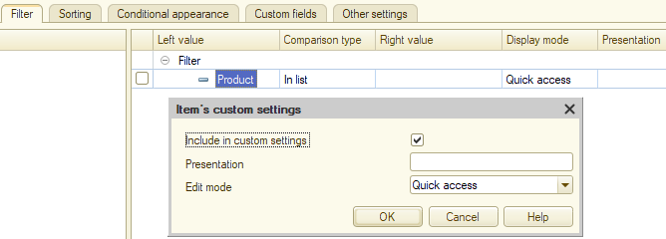
You may have noticed that in the Designer mode, on the Filter tab, there is also a Presentation column. Setting a value in this field allows you to create a "fixed" filter, which the user only turns on or off. For example, for the filter "Amount >= 1000" you can set the view "Only for the amount from 1000", then this filter will be presented to the user with this presentation and a flag, so the user will not be able to change the comparison type (>=, <, etc.) or the right value (1000, 0, …), he will only be able to turn this filter on or off:
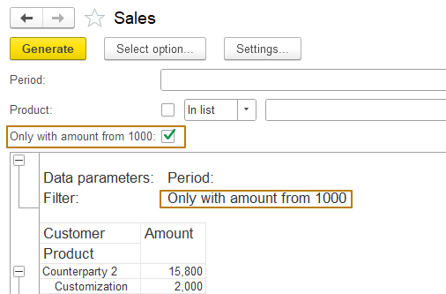
In the Enterprise mode, you can also set such a view by right-clicking on the filter and selecting "Set presentation" or by enabling the "Detailed" flag in the "More actions" submenu, then the composition of the selection table columns will be the same as in the Designer mode:
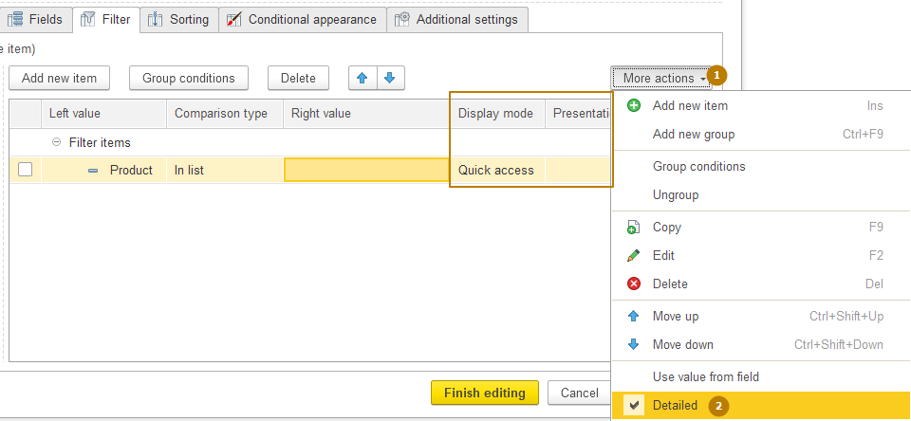
And finally, it is worth noting that the user can independently change the structure of the generated report - add / change / delete groupings, tables, and even diagrams. What the user cannot do is change data sets, parameters, resources, so developers sometimes select some additional fields that are not included in the report by default, but which are highly likely to be needed by individual users, so users can change the report as needed without the developer's participation.
This completes the development of a simple report.

Complex report
Now I will try to demonstrate a report building process using several previously undiscussed areas of the data composition system: a data set of the "object" type, data set links, calculated fields.
So, our infobase does not maintain full-fledged personnel records, instead, it maintains the most simplified records - who works in what department and in what position from what date, or when the employee quit. The main personnel records are maintained in a separate program, not necessarily on the 1C platform, let's call it HRM. In this separate HRM program, data on the hours worked by employees is entered, the salary for the month for payment is calculated, and other operations are carried out.
Let's imagine that I receive a task to modify the configuration for accounting of trade in such a way that it would be possible to enter operational information about bonuses and fines of employees, since employees working in the trade infobase do not have access to the HRM system. In the future, the entered information will be transferred and entered into the HRM system.
In addition, employees require access to information on the recorded time worked and the earned amount for accrual. To implement this requirement, I need to create a report in the trade configuration that will allow users to see the number of hours worked and the amount of money earned in the current month by employees. The report should include only employees who are working on the date of the report generation (on the current date), which is determined by the value of the "Works" resource of the "Employees" information register
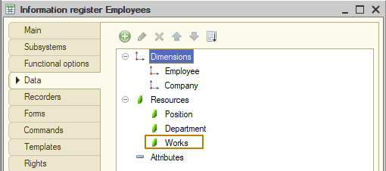
The complete information displayed in the report should look like this: employee, number of hours worked, calculated salary, bonuses/fines (entered in the current program, the number can be negative), amount to be paid calculated using the formula <calculated salary + bonuses/fines>. If the calculation results in the amount to be paid being below zero (i.e. the amount of penalties exceeds the amount of the calculated salary), then the value 0 should be displayed in the report.
Let's also assume that the HRM system has a service that accepts requests and returns a data table in response in the form
Employee - Company - NumberOfHours - CurrentSalary
Then, in order to build the required report, it is necessary to contact the service for part of the data, and get the rest from the information base. The data received from the service is not stored in the information base, so we cannot get it using a query, but we can pass it to the report using a data set of the "Object" type.
To begin with, I created a new Salary subsystem, which is subordinate to the HRM subsystem, I will include in it the objects created within this task. Next, I create a new accumulation register BonusesFinesOfEmployees with the "Turnover" type. Since accumulation registers cannot be independent, I will have to create a document BonusesFinesOfEmployeesRegistration to make records in the register. The register structure should be as follows:
Dimensions: Employee, Company
Resources: Bonus, Fine
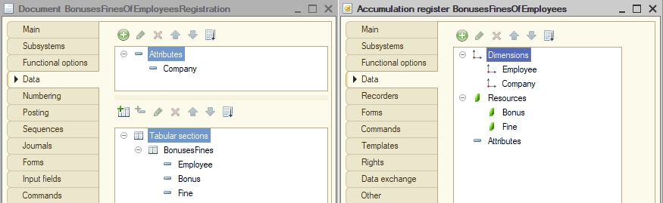
I will not describe the process of creating a document, since we are already very familiar with this area of knowledge. Next, I enter documents to fill the new register with data on employees available in the database
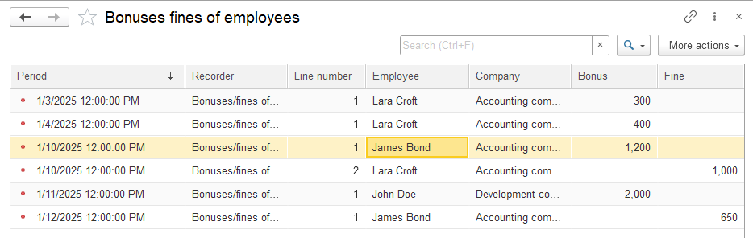
Let's move on to creating a report. I create a new report and call it PlannedSalary, place it in the Salary subsystem. Next, I create the main data composition scheme and add a data set of the "object" type, which I call "CurrentSalaryAccruals"

First of all, I must specify the name of the external data set, by which it will be transferred to the layout scheme from the code, in the "Data object name" field, so I write "PayrollAccrualsFromHRM" there.
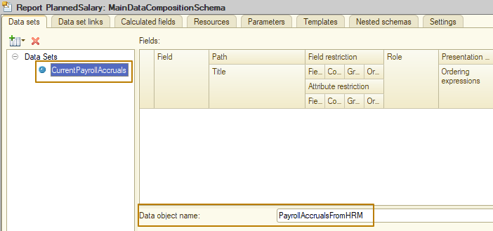
Next, I should fill in the data structure of the new data set, i.e. add fields, specify all the necessary information, for example, the value type:
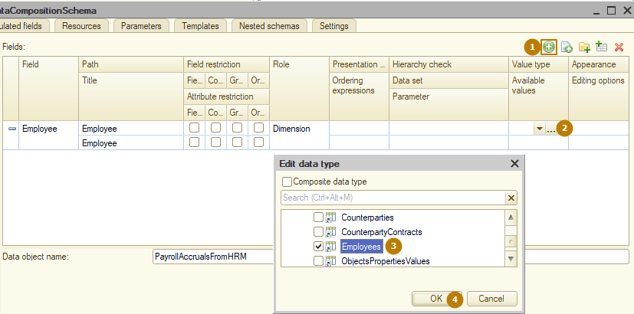
The result is:
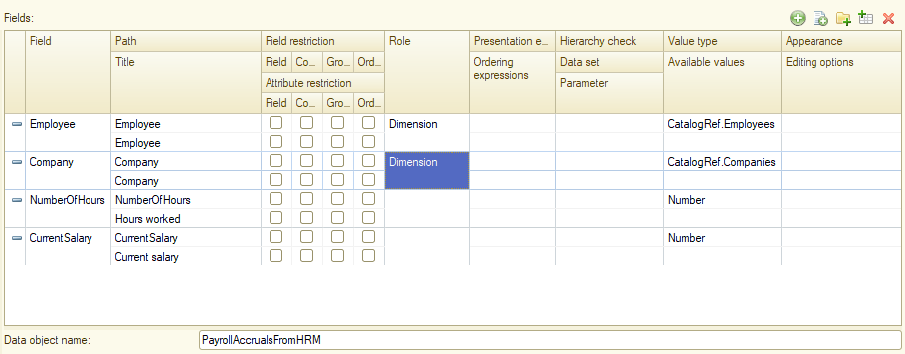
That's it, the "object" data set is ready. Now I need to add a "query" data set to select employees and their bonuses/fines. Since I need to select all working employees, not just those who had bonuses and fines during the period, I create a query for two tables: the "Employees" information register and the new "BonusesFinesOfEmployees" accumulation register.
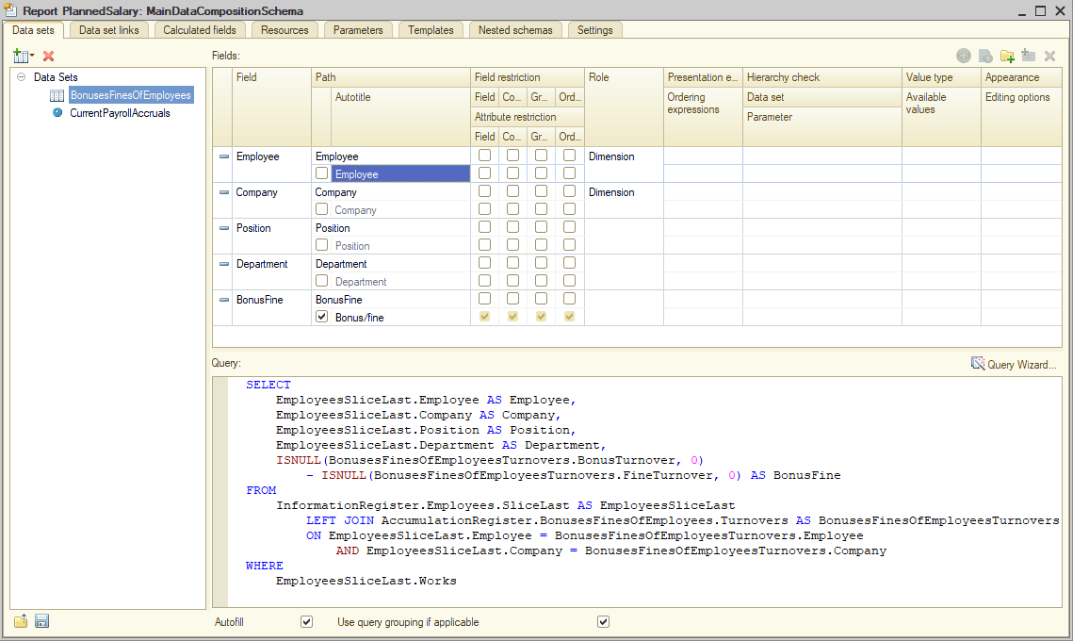
So, I have 2 data sets that I need to connect (not merge) with a left join, leaving the BonusesFinesOfEmployees data set as the main one, i.e. its records should always be included in the result, and the rows of the second data set should be selected only if the values match the connection conditions (employee, company).
In order to connect data sets, there is a "Data set links" tab, where all connections are left joins. The "Link source" field specifies the main table (data set), and the "Link target" field specifies the joined table (data set). The "Source expression" and "Target expression" fields specify the connection fields or expressions in the DCS language.
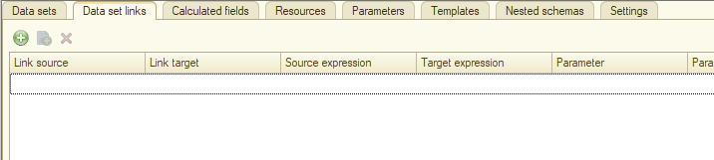
Another feature of linking data sets is row grouping. When linking data sets, each individual set may contain several rows with the same value of the field by which the connection is made. Despite this, only one record of each set is always used when calculating totals, and there is no duplication. The calculation of totals by groupings is correct (unlike joining several tables in one query). This is the main advantage of using linking several data sets.
Data composition
Another feature of data set links is the transfer of a field from the main data set as a query parameter of the joined data set. For example, the main table (data set) contains a list of products, the joined table (data set) receives data by querying the virtual table Turnovers of the Sales accumulation register and receives all sales for a certain period, for example, for the current month.
Then, in order to avoid executing a query that selects turnovers for the entire products and then leaves only those records that are in the main data set, you can pass the product from the main data set as a parameter to the query of the joined data set. To do this, in the "Parameter" field, specify the &Product parameter in the line where the connection by the Product - Product fields is configured, then for each product a query to the table of the latest product will be selected. But this parameter must first be specified in the query. In the case when the parameter should not affect the report generation, i.e. we do not want the user to fill in this parameter and are not going to fill it in programmatically, but use it exclusively to link data sets, you should specify the parameter on the "Data composition" tab of the query:
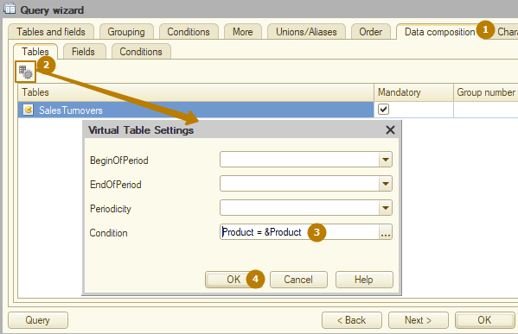
All parameters, fields and conditions from this tab are optional, i.e. the data composition system will provide the ability to use these fields, but will not require their filling or use. This is what the data set links with a parameter looks like:
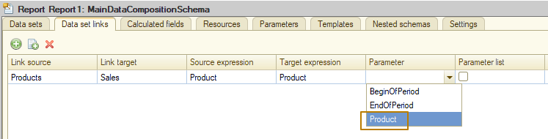
This simplifies development, but may worsen performance, since 1000 queries will be executed for 1000 records.
This situation can be optimized in some cases by enabling the "Parameter list" flag, which is located to the right of the "Parameter" field. Then the queries will be executed not for each row of the main table (data set), but in portions of 1000 records. For example, if there are 1500 records in the main data set, the query to the virtual table of the accumulation register "Sales" will be executed only twice. In this case, you should specify the condition type "IN" instead of equality. In our case, this is Product IN (&Product):
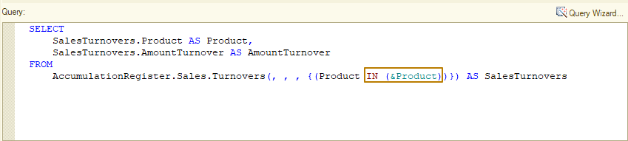
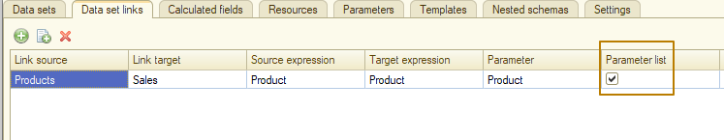
Let's get back to our report and data set links. I specify the BonusesFinesOfEmployees data set as the main one when setting up a data set links for 2 fields: Employee and Company:
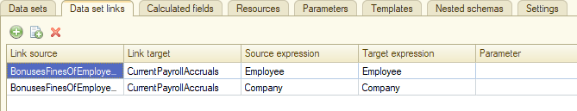
Now I need to add a field to the report whose value is calculated based on fields from different datasets. I can do this using calculated fields.
Calculated fields
When developing reports, the fields defined in the data set are not always enough. Quite often, it is necessary to reflect some other fields that are calculated based on the existing ones using a certain algorithm. For example, it is necessary to calculate revenue as the difference between income and expenses, etc.
For this, the data composition system has the ability to define a calculated field. Calculated fields are additional fields of the data composition schema, the values of which will be calculated using a certain formula. In the data composition settings, the calculated field will appear under the name specified in the path to the data of this field. The user will be able to work with the calculated field in the same way as with the field of the data set.
In order for the system to be able to obtain the value of the calculated field, it is necessary to specify the expression of the calculated field. It is described in the language of data composition expressions. There is a limitation in the expressions of the calculated field: other calculated fields cannot be used in it. Otherwise, there are no restrictions: you can use all the syntax constructs of the expression language, you can use data set fields, as well as the functions of the common modules of a configuration described with the Export keyword.
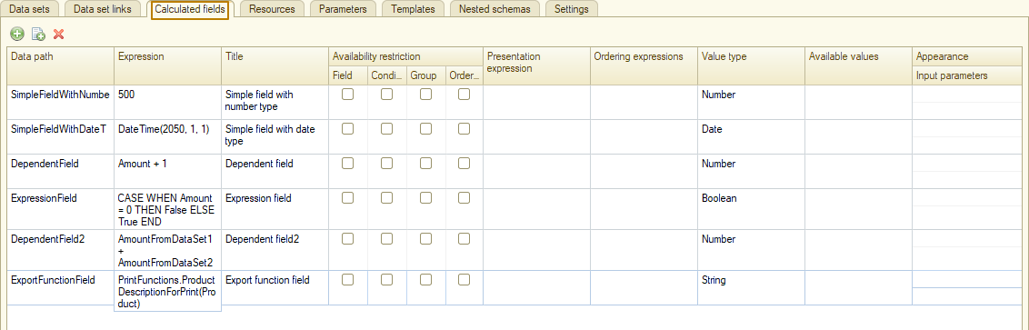
For a calculated field, you can define a title, availability restriction, presentation expression, ordering expressions, value type, available values, and formatting in the same way as for dataset fields. In addition, a calculated field can be defined as a resource. To do this, you need to add this field to the list of resources and specify the expression by which the total will be calculated.
You probably remember that on the resources tab, you can also use an expression in the DCS language, that is, in cases where there is no need for a new field, you can calculate a value in some resource without creating a calculated field. However, in cases where you need a new field that is not in the datasets, or when you need to calculate a value for a field, but the field should not be a resource, you should use calculated fields.
Let's go back to our report, I add the AmountToPay field, in the expression of which I write CurrentSalary + BonusFine. Please note that the platform warns about using non-existent fields in calculated fields:
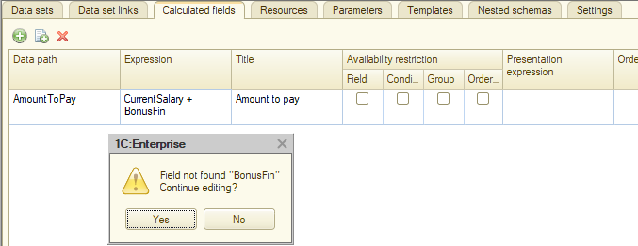
I specify the value type of the new field - Number(10, 0)
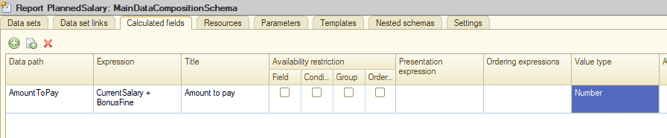
After that, I go to the Resources tab, where I select all the fields available for calculation:
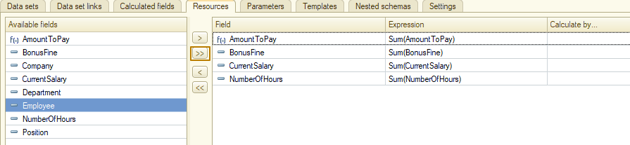
Next, I need to fill in the parameters with dates in such a way that the current date would be transferred to the parameter of the virtual table of the Employees information register (so that the report displays only working employees), and the beginning of the current month and the current date would be transferred to the parameters of the BeginOfPeriod and the EndOfPeriod of the virtual table of the accumulation register, respectively. To do this, I again resort to the parameter Expression field and write the CurrentSessionDate() function for the Period and EndOfPeriod parameters, and for the BeginOfPeriod parameter it’s <BeginOfPeriod(CurrentSessionDate(), "Month")>:
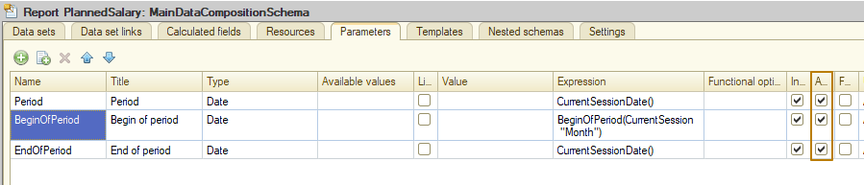
Since the report is always generated relative to the current date, I disable the availability of the parameters by enabling the "Restrict availability" flag.
Now I go to the Settings tab, specify the name of the report variant "PlannedSalaryByCompanies", and add report groupings: the first grouping is Company, and then the Employee grouping nested in it, to which I also want to display the Position and Department fields.
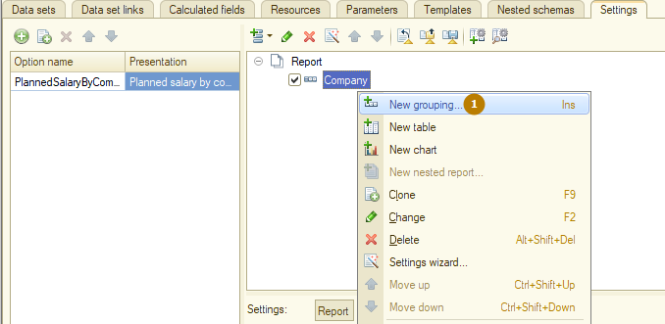
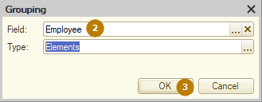
To do this, I open the added grouping by double-clicking/pressing the "Edit" button (pencil icon)/pressing the F2 key and in the window that opens, I add the necessary fields:
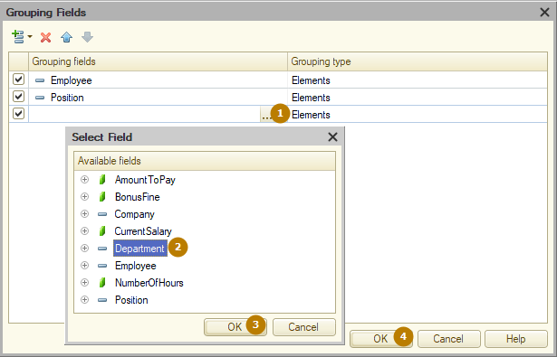
Next, I add resources to the selected fields, but I want to separate the fields with amounts from the field with hours by combining them in a group. To do this, I select the required fields and right-click - "group fields", after which a new group is added to the list, and the selected fields are moved to it. I specify the title of the added group - "Salary".
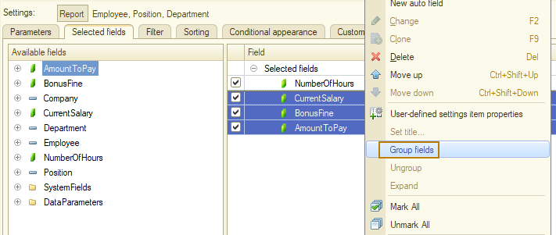
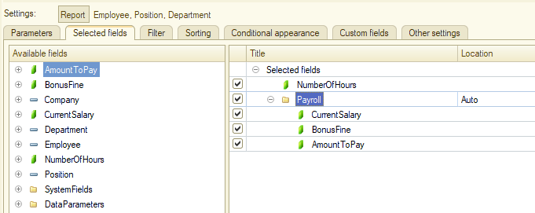
On the Filter tab, I add filters by company and employee, include them in the user settings, but disable these filters by default (uncheck the flags).
The report structure is ready, now I need to make it so that when generating a report, a data set of the "object" type is transferred to it, otherwise the report will not work and the user will receive an error when generating it:
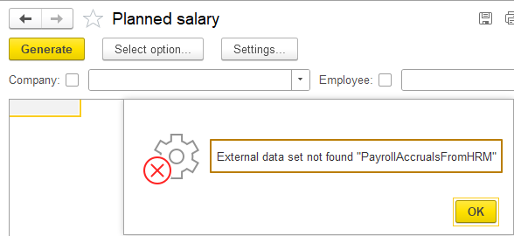
To do this, I go to the report object module and add the OnComposeResult event handler, which is triggered when the report is generated, called by the ComposeResult() method.
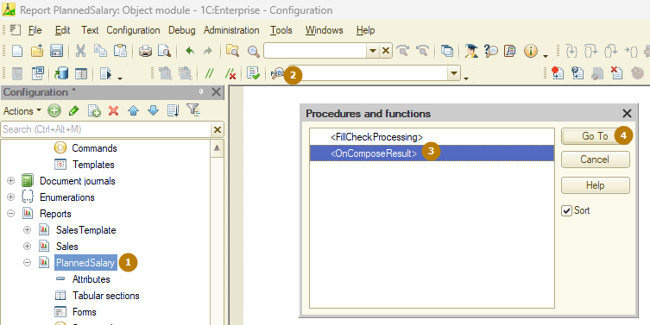
The ComposeResult() method is key for working with reports created using the data composition system (DCS). This method starts the report generation process: from executing a query to the database to receiving the result.
In the OnComposeResult procedure, my task is to go through the key steps of report generation, which were shown in the DCS diagram at the very beginning of the lesson. First, you need to set the StandardProcessing parameter to False so that the report is generated using the algorithm from the code, and not the standard algorithm.
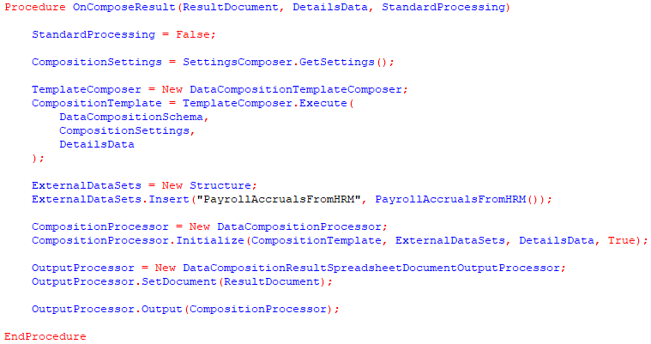
Next, I get the settings of the settings composer into a variable, then create a new DataCompositionTemplateComposer and call the method for its execution to get the generated DataCompositionTemplate. I pass the report data composition schema, composition settings and report details data from the parameter of the OnComposeResult procedure to this Execute() method.
Note: DetailsData. When forming a spreadsheet document using the data composition system, special objects of the type DetailsIdentifier are placed in the cell details. At the same time, the field values themselves and the grouping fields are not in the spreadsheet document. You can get the field values from the DetailsData object, which was filled in when the report was output.
The next step is to initialize the data composition processor, but first I need to create a structure that contains external data sets to pass to the initialization method. The structure key name must match the name of the data object from the object data set, and the value must contain one of the allowed values, in our case it is ValueTable.
I created a function that returns such value table, of course I do not have any external HRM system as described in our hypothetical problem, so inside the function I simply select all working employees and fill in their working hours and calculated salary randomly using a random number generator:
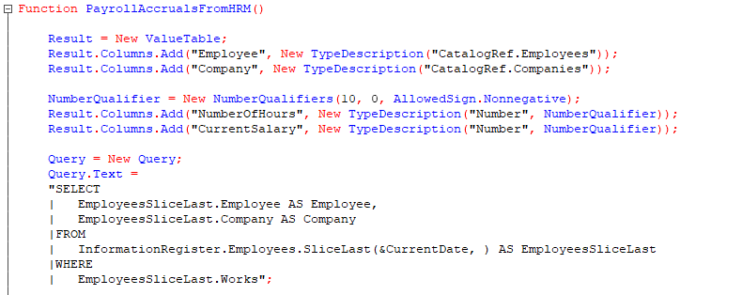
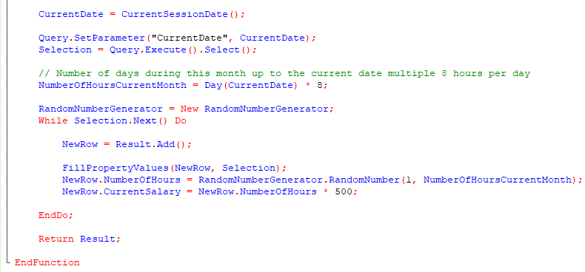
As a maximum number for the random number generator, I use the number of days in the current month before today's date multiplied by 8 hours. For example, if today is the 20th day, then the maximum value is 20 * 8 = 160. Let me remind you that we are not particularly interested in the data in this table, but rather that it exists to demonstrate how to work with external data sets.
Let's get back to generating the report programmatically.
I create a DataCompositionProcessor and initialize it by passing the structure of external data sets to it. Then I create a DataCompositionResultSpreadsheetDocumentOutputProcessor, set a spreadsheet document for it - this is the ResultDocument parameter, which stores the report spreadsheet document, and then output the composition result to this spreadsheet document. If I wanted to output the report result not to a spreadsheet document, but to a collection (ValueTable or ValueTree), I would create an object of the DataCompositionResultValueCollectionOutputProcessor type, read more in the syntax assistant.
Let's move on to checking the changes made, I update the configuration and run the report in Enterprise mode.
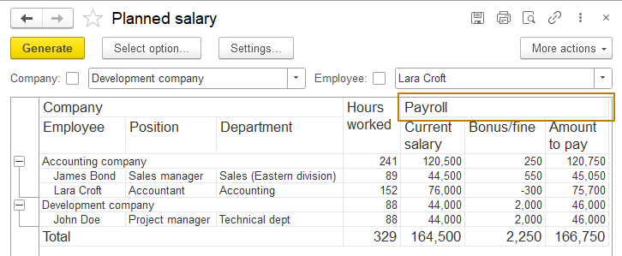
The report is built correctly, the external data set was transferred to the report. Hours worked were filled randomly, accrued salary is based on the number of hours worked, the amount to be paid is calculated taking into account bonuses/penalties. Filters by company and employee also work correctly.
This completes the current task of developing the report.
Characteristics in the report
In a report based on the data composition system, you can use the characteristics of objects, such as the color or size of shoes. If the characteristics are specified for the object in the characteristics window, as we studied in the lesson on chart of characteristic types, then you do not need to do anything else, the characteristics will be available in the report according to the objects you are working with.
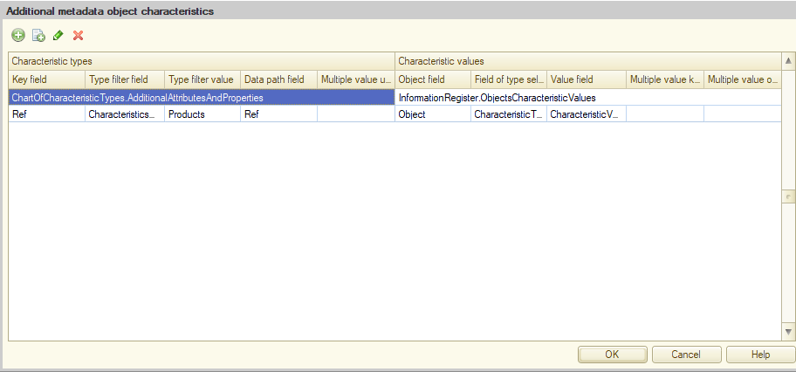
That is, the characteristics belonging to the Products catalog will be available when working with it as attributes included in it, and the characteristics of other objects will not be visible.
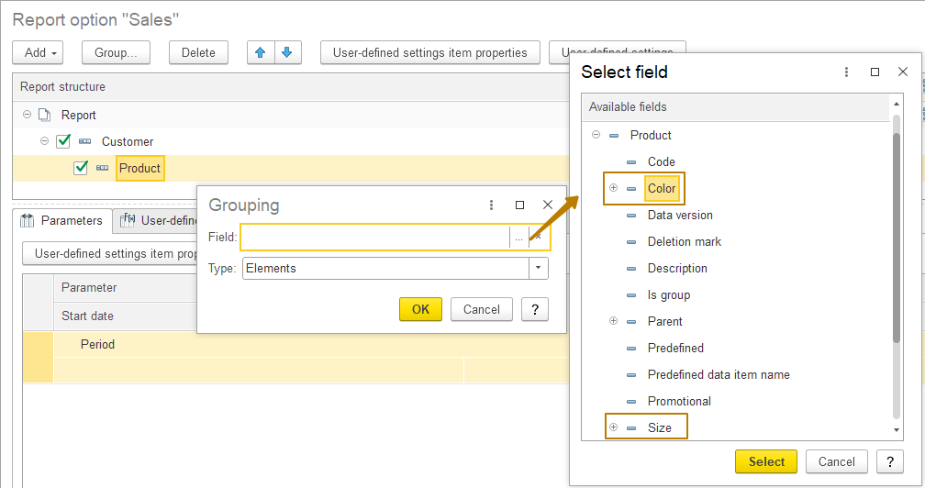
Note: the characteristics will be available as component parts of the object when working from the Enterprise mode, in the Designer mode this will not be possible. If the characteristics are not specified for the object in the characteristics window, they can be added to the report on the Characteristics tab of the query when working from the query console. In this case, you can work with the characteristics only from this report.
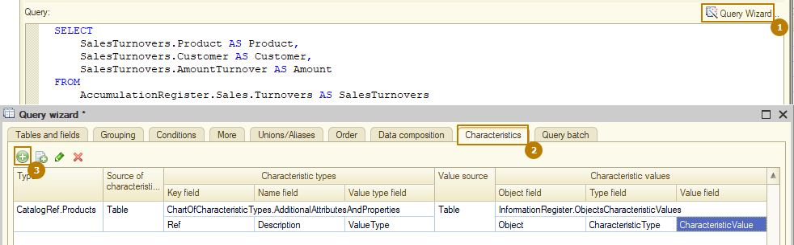
Here is what the query text looks like, in which the characteristics are specified:
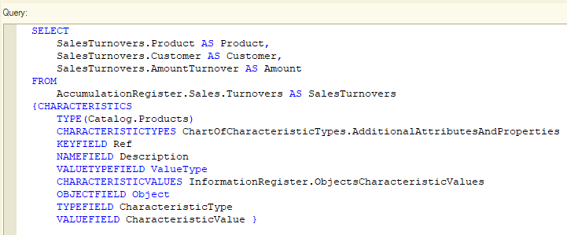
I recommend specifying the characteristics directly in the objects for more convenient work with them from any reports and dynamic lists.
Let's briefly consider the "Table" report type using the Product characteristics as table columns.
I open the "Sales" report settings in Enterprise mode, delete the previously created groupings of the report and add a new table. I make the product the rows of the table, and the "Color" characteristic of the product the columns. That is, the report will show product sales broken down by color.
Since the "Color" characteristic is not specified for all products in my infobase, the report contains a column with an empty header, which indicates that the "Color" characteristic value is not specified for these product items.
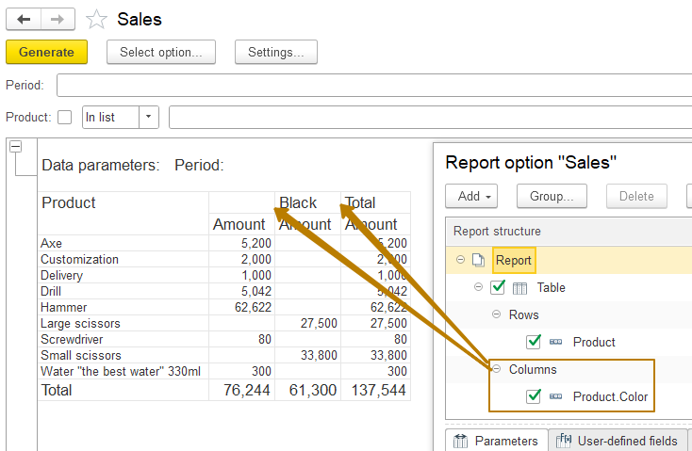
If there were 2 resources in the report, for example, quantity and cost, then for each column with color both would be displayed.
Report design
Now let's take some time to work on the report appearance.
At the moment, the report looks too monotonous, there is no visual distinction between headings, grouping levels, or totals. To fix this, you can use the settings from the Other/Additional settings tab, which is available to both a developer (in the Designer mode) and a user (in the Enterprise mode):
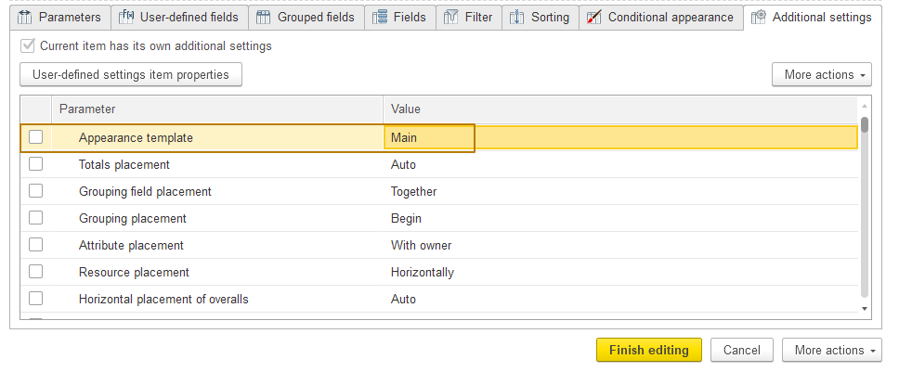
By default, the "Appearance template" property in reports takes the value "Main", but in configurations where the developer did not create metadata objects of the "Style" type, such a template does not contain colors, so the report remains simply white, as if the "Without appearance" value was selected. I won't go into detail about the styles, so I'll just choose one of the most neutral designs - "Antique" and generate the report again:
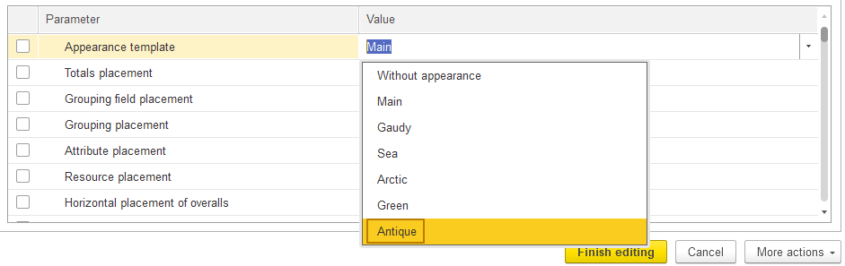
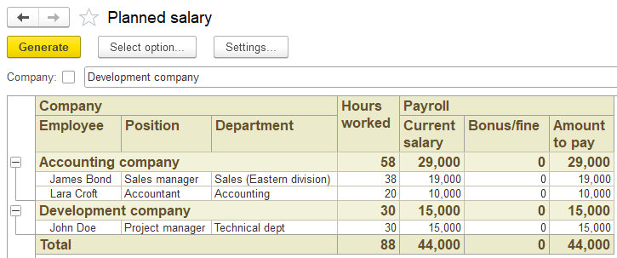
Now the report uses different colors and bold font for headings/different levels of groupings/totals. The information is easier to perceive when it is in this form.
There is often a need to highlight individual lines/cells in a report, for example, in a report on the balances of goods in warehouses, to display negative balances in red text. Here, conditional appearance comes to the rescue, which, like additional settings, is available to the developer and the user:
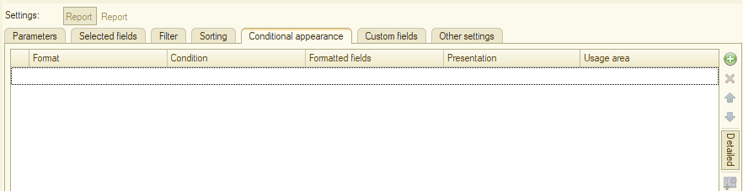
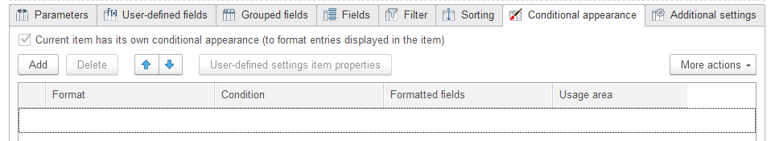

Conditional formatting consists of 4 settings:
- Format - what formatting should be applied, for example: background color, text color, font, cell format, even the text that should be displayed in the cell as a value and much more
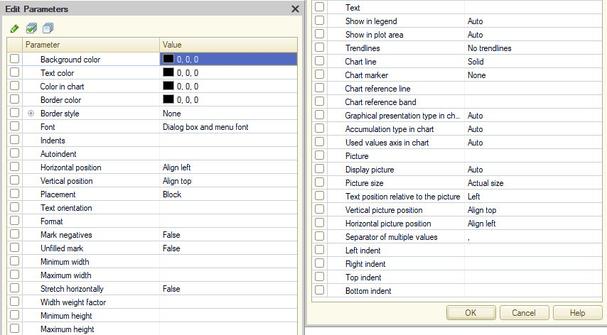
- Condition - if the condition is met, the formatting will be applied, otherwise it will not. For example, Balance < 0
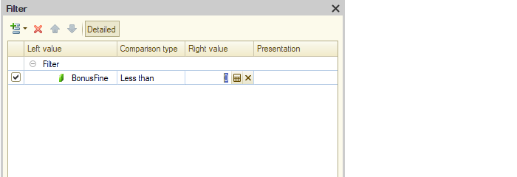
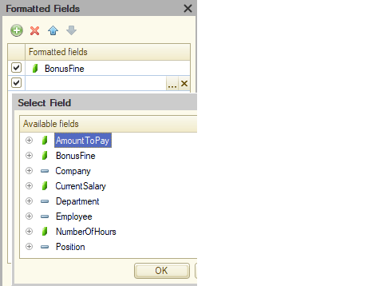
- Formatted fields - fields for which the specified formatting will be used

- Usage area - in which areas of the report to apply the formatting: in groupings, in hierarchical groupings, in totals, in field headers, in resource field headers, in totals headers, in totals resource field headers, in the header, in parameters, in filter…
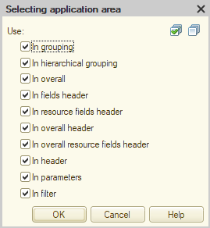
Before looking at examples of conditional appearance, I would like to touch on the topic of roles in the data composition system, since I plan to create a new report within this topic. Based on this report, I will demonstrate an example of working with conditional appearance.
Roles of fields
In the data composition system, you can set a role for each dataset field. The field role specifies how the field should be interpreted when composing a report. The platform sets some role properties automatically. To edit them, in the data composition schema designer, on the Data sets tab, click the selection button in the Role field of the desired data set field:
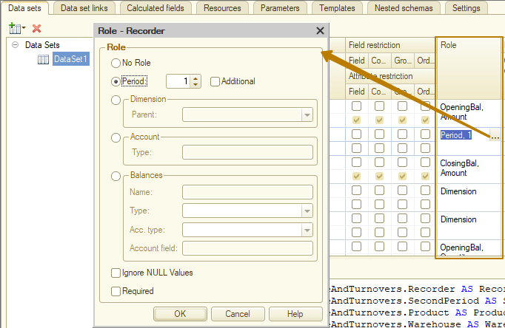
The field role contains the following properties:
- Without role – the field has no role;
- Period – a number containing the period number if the field is a period field. The value 0 means that this field is not a period. The youngest period must have the number 1. Its parent period is 2, etc. For example, for a query that receives data from the Balances and Turnovers virtual table, the Period field must have a period number of 3, the Recorder field must have a period number of 2, the LineNumber field must have a period number of 1. If LineNumber is not used, then the Recorder is 1, PeriodSecond is 2, etc. Based on this information, the platform will calculate the totals for the balance fields;
- Additional – an indicator that this period field is optional. Setting this indicator means that the field does not have to be used in the data composition if its child periods are used in the report. Otherwise, using a child period field means that this field must also be used in the grouping;
- Dimension – an indicator that the field is a dimension. The information that the field is a dimension is used when calculating the totals for the resources fields;
- Ignore NULL values – an indicator that the result should not include group records for this field if the field contains a NULL value;
- Required – indicates the need to add this field to the data set of a data composition template if at least one field from the data set is used in the settings. It is important to remember that the data composition system excludes fields from the resulting query that are not included in the report settings. In some cases, this can lead to errors.
I intentionally skipped the "Account" and "Balances" roles, since we won't have time to cover them in this lesson anyway. One of the key roles, which sometimes requires manual configuration from the developer, is the Period role.
To demonstrate the purpose of this role, I will create a new "Goods movement" report containing information on the opening and closing balances of goods for the report period, as well as their receipts and expenses during the period. I create a main data composition schema of the report, add a Query data set, and select data on the quantity and amount of goods by warehouses and documents that performed movements in the register (Recorder). In order to be able to select a recorder in the Turnovers and BalanceAndTurnovers virtual tables of the accumulation registers, it is necessary to set the periodicity in the virtual table parameters to one of the values: Recorder, Record, Auto.
Important: the periodicity is responsible for how the register resources will be grouped as a result of the query. For example, with the Recorder periodicity, the resources will be grouped according to the dimensions and the recorder selected in the query (provided that it is included in the selected fields).
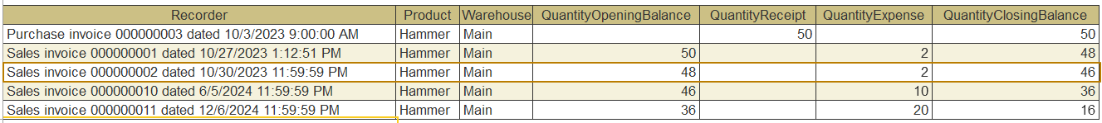
With the Record periodicity - the same, but also up to the record number (provided that the LineNumber field is included in the selected query fields).
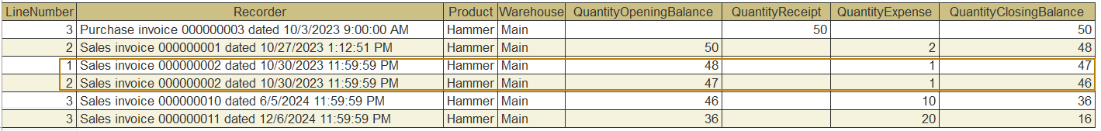
With the Auto periodicity, it becomes possible to select different periods, for example, Second, Hour, Day, Month, etc., and the records are grouped up to the selected dimensions and periods (if different periods are selected, then up to the most detailed of them).
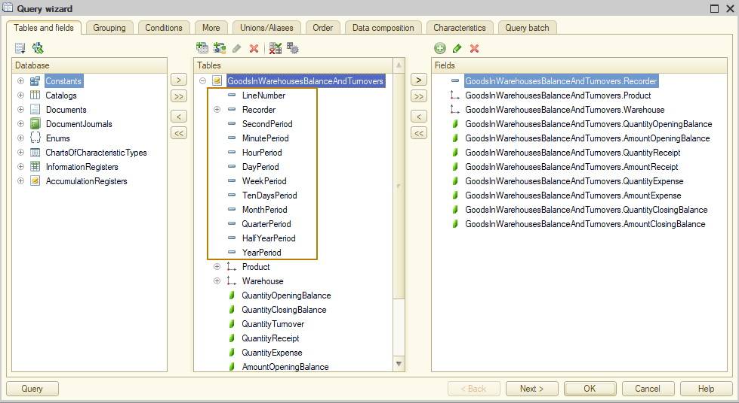
I set the frequency to "Auto" and select the Recorder, Product, Warehouse in the query, as well as the opening and closing balances, receipts and expenses for the quantity and cost of goods:
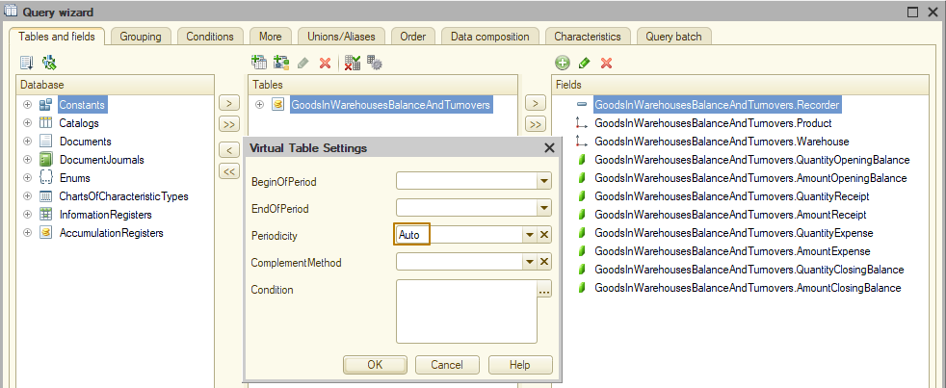
I also want to share a way to combine fields in a report into groups for more convenient work with them. To do this, I need to enter the desired name in the "Path" field of the data set myself in the format GroupName.FieldName, for example, Receipt.Quantity, Expense.Quantity. Subsequently, on the Settings tab, these fields will be included in groups as shown in the picture:
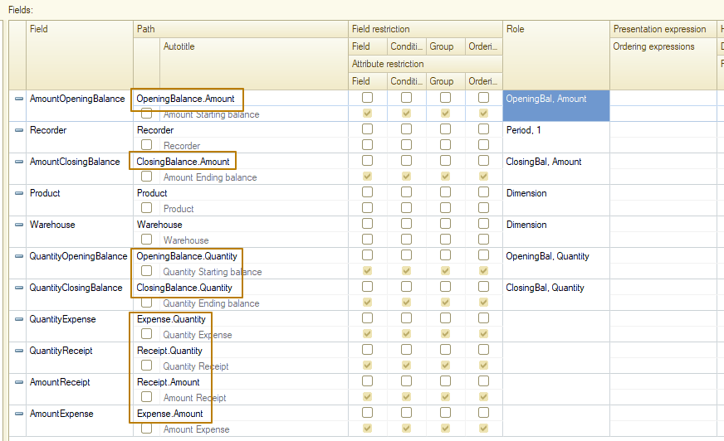
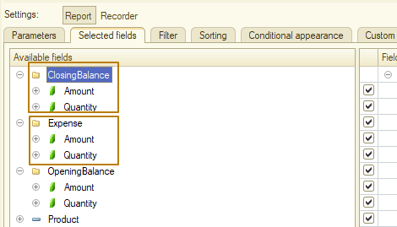
Next, I specify the report resources and proceed to setting up the structure, where I add three levels of grouping: Warehouse - Product - Recorder. Then I select the report resources as selected fields, but I want the resource fields to be grouped into "Beginning of period", "Receipt", "Expense" and "End of period", and the resources included in these groups to have the headings "Quantity" and "Amount" instead of full synonyms "Quantity opening balance" etc., since in this case the report will take up too much space horizontally.
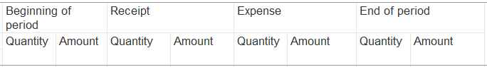
Now I group the fields in the same way as I did in the salary report, and then set the headings for these fields using the "Set title" button:
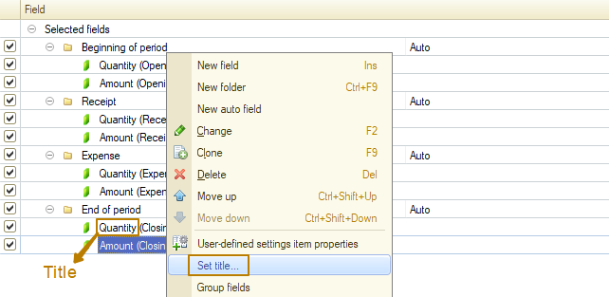
I do this to replace the output of autotitles from the data set. I could set my own title for the fields directly in the data set by enabling the flag under the "Path" field and assigning the title in the field that becomes available, but the disadvantage of this approach is that if you assign the same header to different fields (and in my case I will have 4 Quantity columns and 4 Cost columns included in column groups), then the user in the Enterprise mode will not be able to distinguish these fields from each other, they will all look the same to him: Quantity and Cost respectively:
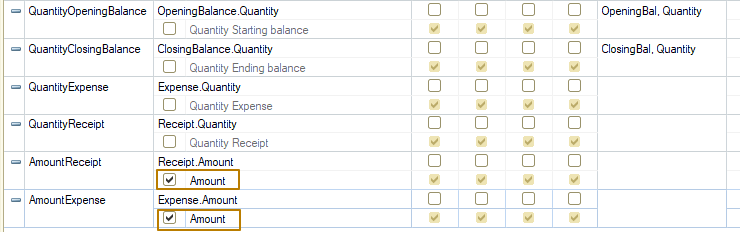
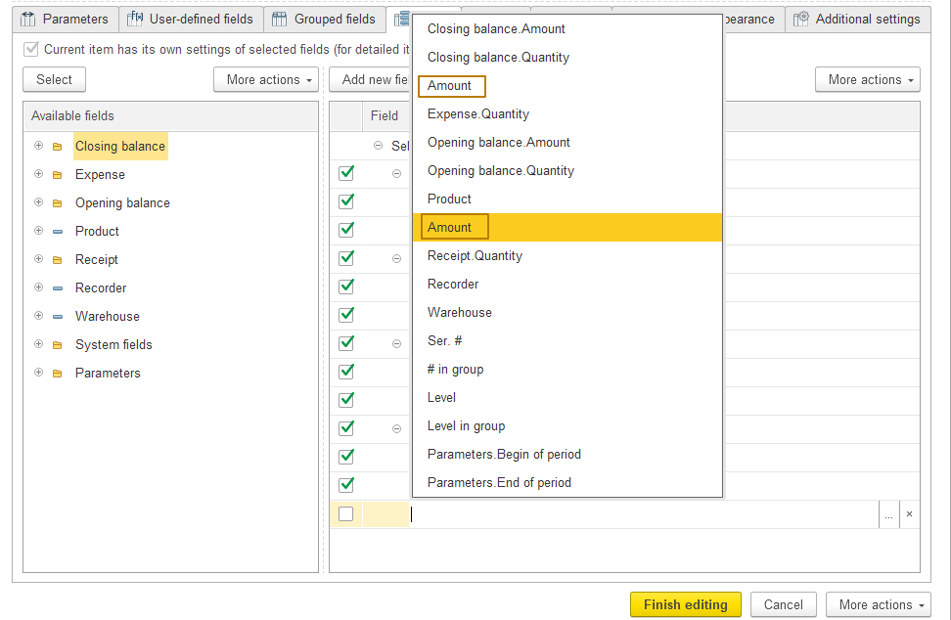
The last step is to set the "Antique" appearance template, and then update the configuration and generate the report in the Enterprise mode. The report has the structure "Balance at the beginning of the period" - "Receipt within the period" - "Expense within the period" - "Balance at the end of the period". Accordingly, if I generate a report without a period limitation, then for each product the initial balance should be 0, then some receipts and expenses, and the final balance changes in accordance with this data.
And here I encountered a problem with calculating totals when the grouping contains totals that are opposite to the correct ones, because the "Beginning of the period" group contains totals based on the data as of the moment after the last record in this grouping, and the "End of the period" group, on the contrary, contains data as of the moment after the first record in this grouping.
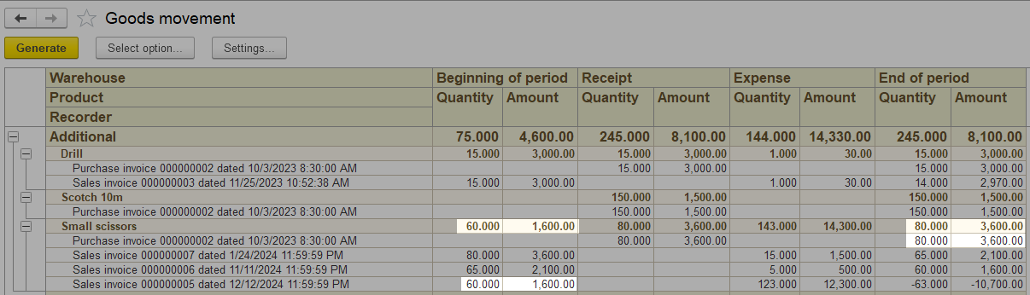
This happens because the data composition system cannot correctly calculate totals without having per-second data, by which the opening and closing balances should be calculated. Let's modify the report using the field role mechanism so that the information is correct. To do this, I select the PeriodSecond field in the query, after which the platform automatically assigns the "Period, 2" role to this field.
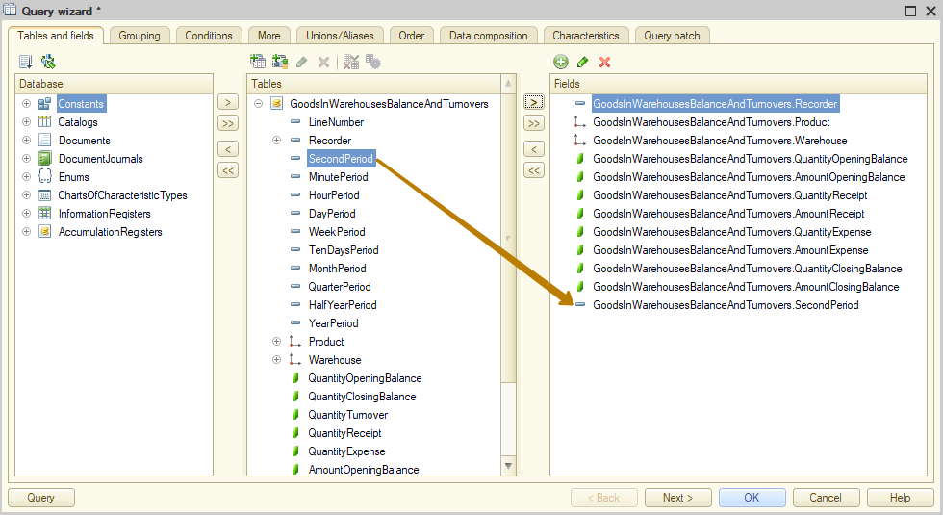
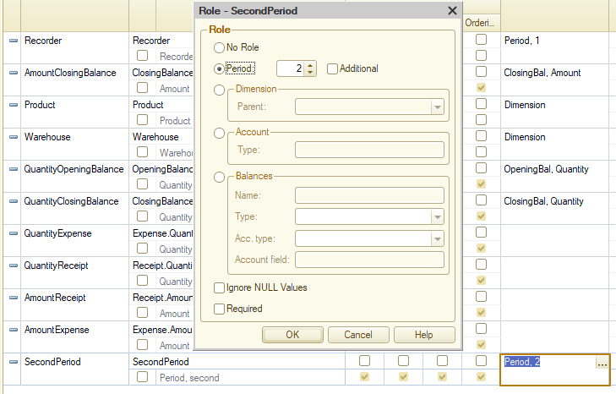
The number in this case means the order of the period, i.e. the Recorder with the role "Period, 1" comes first, and then this field PeriodSecond. The "additional" flag is unchecked, which means that the totals will be calculated by this field, even if it is not selected in the report. If you now select another period field other than seconds, for example, PeriodDay, the platform will set the "Additional" flag for it, because a more detailed period of seconds is already used for the calculation and there is no need to use the period by day when calculating the totals.
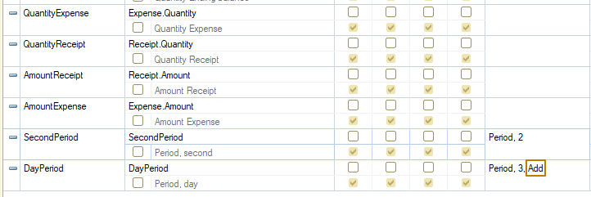
I delete the PeriodDay field, because I do not need it in the report, update the configuration and generate the report again to check the correctness of the data in the totals.
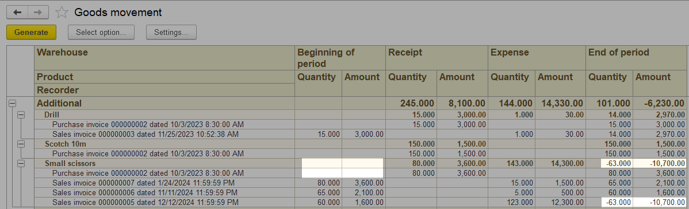
As you can see, now the totals in the groups are calculated correctly taking into account the periods of records, since at the beginning of the period there are no balances of quantity and amount for the product, and at the end of the period they are equal to the balances after the last record.
Report design (continued)
You may have noticed that I have negative balances for some products. Let's use conditional appearance to highlight such values in the report, so that it is easier for the user to find such data in the report.
I add a new line in the "Conditional appearance" list, in the Format column I set the text color to red. In the list of colors there is a predefined color named "Negative number":
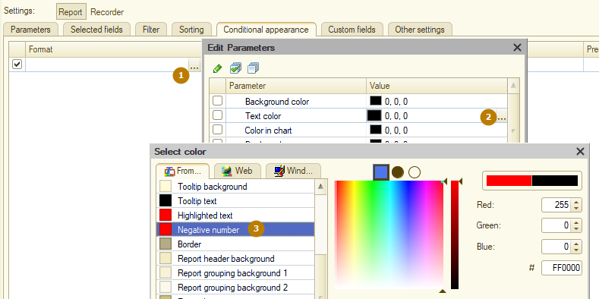
The next step is to specify the condition under which the design will be applied. But there is a nuance: I do not want having a negative value in one column, for example, "Expense Amount", to highlight the value in another column, for example, "Cost opening balance". This means that in the current row I can use only one column, for example, in the condition specify "OpeningBalance.Quantity Less than 0" and in the "Formatted fields" field specify the "OpeningBalance.Quantity" field.
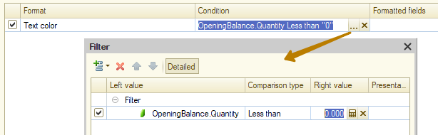
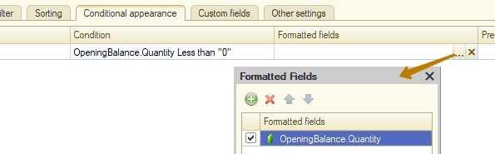
But then I will have to make separate lines for each of the other formatted fields, i.e. a total of 8 conditional appearance lines. It doesn't look very convenient, does it?
For ease of working with such a design, the Format window contains auxiliary formatting, such as "Mark negatives", which allows you to highlight negative values in red text without creating a condition, it is enough to specify only the fields, and the condition for a negative value will be checked automatically by the platform:
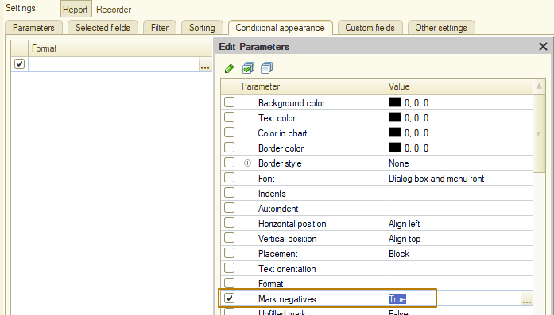
Thus, one line of conditional appearance is enough, if necessary, you can specify the area of use of the formatting, for example, disable the mark of negatives in the totals of groups. I will not change the area of usage and will leave the formatting for all areas for the selected fields:
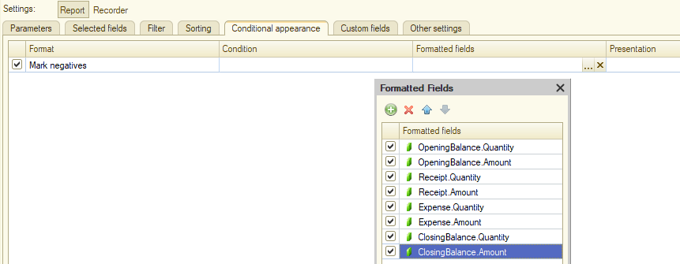
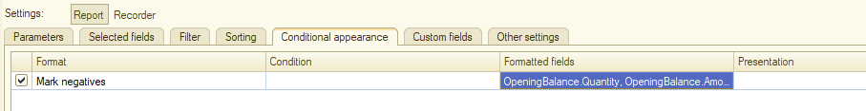
I update the configuration and check the result, I see that everything works as expected
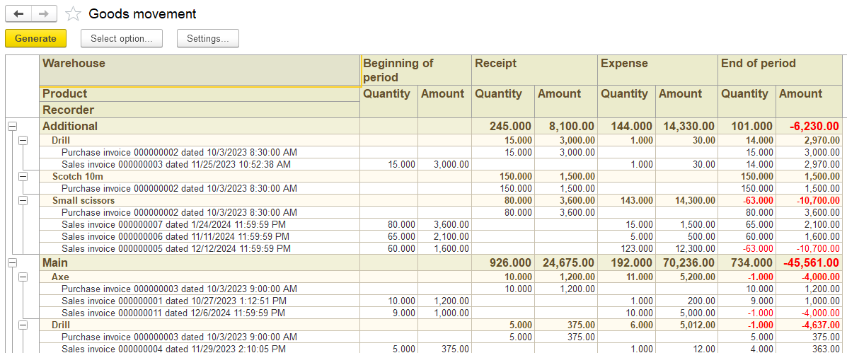
But what if a user specifies his requirement in terms of highlighting negative balances - it is necessary to highlight negative balances only in the Recorder and Product groupings, and there is no need to use conditional appearance in the Warehouse grouping? In this case, we can use the settings of individual groupings instead of the report settings as a whole. To do this, select the desired grouping in the report structure list and go to its own settings.
Report settings:
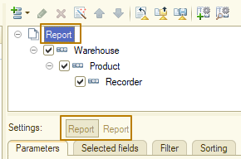
Grouping settings:
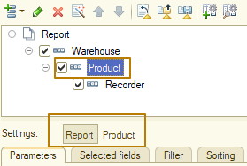
In the grouping settings, perform the necessary actions. In my case, I add exactly the same conditional appearance line that I previously added in the report settings.
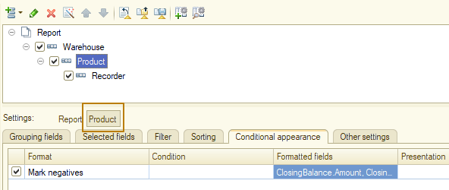
After that, I repeat the action for the Recorder grouping, and then delete the conditional appearance line from the general report settings.
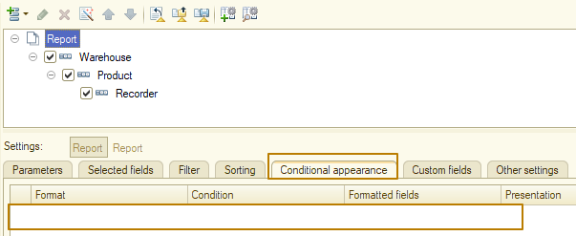
Let's check what we got. You can see that now negative balances are not highlighted in the Warehouse grouping, while they are highlighted in the Product and Recorder groupings.
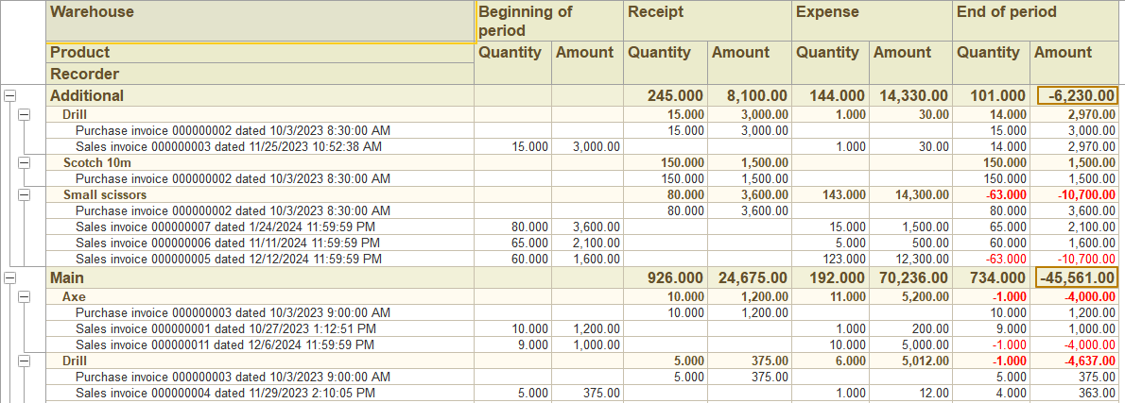
That's it, explore other possibilities of conditional appearance and other grouping settings yourself.

